**The simple answer:** the calculations for both the sample standard deviation and the sample variance both contain a little [bias](https://www.statisticshowto.com/what-is-bias/) (that’s the statistics way of saying “error”). Bessel’s correction (i.e. subtracting 1 from your sample size) corrects this bias. In other words, **you’ll usually get a more accurate answer if you use *n-1* instead of *n*.**

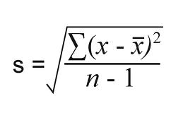

For small sample sizes, Bessel’s correction is going to be quite severe. If you have a small sample, it’s highly unlikely that it’s going to be a very good estimate of the population mean anyway.

The formula to calculate **population variance** is:

**σ2** = Σ (xi – μ)2 / N

The formula to calculate **sample variance** is:

**s2** = Σ (xi – x)2 / (n-1)

When we calculate population variance, we divide by **N** (the population size).

When we calculate sample variance, we divide by **n-1** (the sample size – 1).

When calculating the sample variance, we apply something known as [Bessel’s correction](https://en.wikipedia.org/wiki/Bessel%27s_correction) – which is the act of dividing by n-1.

You should calculate the **sample variance** when the dataset you’re working with represents a a sample taken from a larger population of interest.

You should calculate the **population variance** when the dataset you’re working with represents an entire population, i.e. every value that you’re interested in.

Normal distribution, also known as the Gaussian distribution, is a [probability distribution](https://www.investopedia.com/terms/p/probabilitydistribution.asp) that is symmetric about the mean, showing that data near the mean are more frequent in occurrence than data far from the mean.

In graphical form, the normal distribution appears as a "[bell curve](https://www.investopedia.com/terms/b/bell-curve.asp)".

First, its [mean](https://www.investopedia.com/terms/m/mean.asp) (average), [median](https://www.investopedia.com/terms/m/median.asp) (midpoint), and [mode](https://www.investopedia.com/terms/m/mode.asp) (most frequent observation) are all equal to one another. Moreover, these values all represent the peak, or highest point, of the distribution. For all normal distributions, 68.2% of the observations will appear within plus or minus one standard deviation of the mean; 95.4% of the observations will fall within +/- two standard deviations; and 99.7% within +/- three standard deviations. This fact is sometimes referred to as the "empirical rule," a heuristic that describes where most of the data in a normal distribution will appear.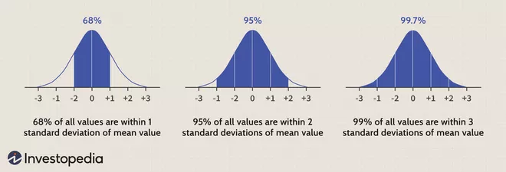

### Skewness

[Skewness](https://www.investopedia.com/terms/s/skewness.asp) measures the degree of symmetry of a distribution. The normal distribution is symmetric and has a skewness of zero.

### Kurtosis

[Kurtosis](https://www.investopedia.com/terms/k/kurtosis.asp) measures the thickness of the tail ends of a distribution in relation to the tails of a distribution. The normal distribution has a kurtosis equal to 3.0.

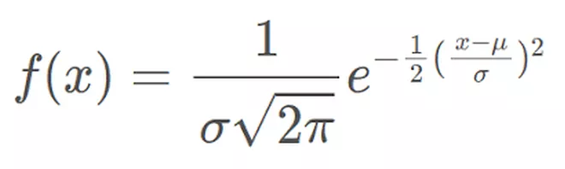

where:

* *x* = value of the variable or data being examined and f(x) the probability function
* μ = the mean
* σ = the standard deviation

## **Ridge Regression**

Similar to the lasso regression, ridge regression puts a similar constraint on the coefficients by introducing a penalty factor. However, while lasso regression takes the magnitude of the coefficients, ridge regression takes the square.

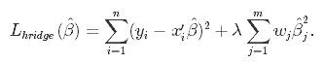

Ridge regression is also referred to as **L2 Regularization**.

### The differences between L1 and L2 regularization:

* L1 regularization penalizes the sum of absolute values of the weights, whereas L2 regularization penalizes the sum of squares of the weights.
* The L1 regularization solution is sparse. The L2 regularization solution is non-sparse.
* L2 regularization doesn’t perform feature selection, since weights are only reduced to values near 0 instead of 0. L1 regularization has built-in feature selection.
* L1 regularization is robust to outliers, L2 regularization is not.

# Multicollinearity in Regression Analysis: Problems, Detection, and Solutions

By [Jim Frost](https://statisticsbyjim.com/author/statis11_wp/) [190 Comments](https://statisticsbyjim.com/regression/multicollinearity-in-regression-analysis/#comments)

Multicollinearity occurs when independent variables in a [regression](https://statisticsbyjim.com/glossary/regression-analysis/) model are correlated. This [correlation](https://statisticsbyjim.com/glossary/correlation/) is a problem because independent variables should be *independent*. If the degree of correlation between variables is high enough, it can cause problems when you fit the model and interpret the results.

Multicollinearity makes it hard to interpret your coefficients, and it reduces the power of your model to identify independent variables that are statistically significant. These are definitely serious problems.

When independent variables are highly correlated, change in one variable would cause change to another and so the model results fluctuate significantly. The model results will be unstable and vary a lot given a small change in the data or model. This will create the following problems:

1. It would be hard for you to **choose the list of significant variables** for the model if the model gives you different results every time.
2. **Coefficient Estimates would not be stable** and it would be hard for you to interpret the model. In other words, you cannot tell the scale of changes to the output if one of your predicting factors changes by 1 unit.
3. The unstable nature of the model may cause **overfitting**. If you apply the model to another sample of data, the accuracy will drop significantly compared to the accuracy of your training dataset.

## **How to check whether Multi-Collinearity occurs?**

**The first simple method** is to plot the correlation matrix of all the independent variables.

*When you are clueless about which variables to include in the model, just do a correlation matrix and select those independent variables with high correlation with dependent variable.*

***The second method*** *to check multi-collinearity is to use the Variance Inflation Factor(VIF) for each independent variable. It is a measure of multicollinearity in the set of multiple regression variables. The higher the value of VIF the higher correlation between this variable and the rest.*

## ***How to fix the Multi-Collinearity issue?***

1. ***Variable Selection***

*The most straightforward method is to remove some variables that are highly correlated to others and leave the more significant ones in the set.*

*2.* ***Variable Transformation***

*The second method is to* ***transform some of the variables to make them less correlated but still maintain their feature****.*

*3.* ***Principal Component Analysis***

*Principal Component Analysis(PCA) is commonly used to reduce the dimension of data by decomposing data into a number of independent factors.*

*Batch normalization is a technique for training very deep neural networks that standardizes the inputs to a layer for each mini-batch. This has the effect of stabilizing the learning process and dramatically reducing the number of training epochs required to train deep networks.We refer to the change in the distributions of internal nodes of a deep network, in the course of training, as Internal Covariate Shift.*

*Batch normalization provides an elegant way of reparametrizing almost any deep network. The reparametrization significantly reduces the problem of coordinating updates across many layers.*

*Batch normalization can have a dramatic effect on optimization performance, especially for convolutional networks and networks with sigmoidal nonlinearities.*

## ***Introduction to Cyclical Learning Rates***

*The objectives of the cyclical learning rate (CLR) are two-fold:*

* *CLR gives an approach for setting the global learning rates for training neural networks that eliminate the need to perform tons of experiments to find the best values with no additional computation.*
* *CLR provides an excellent learning rate range (LR range) for an experiment by introducing the concept of* ***LR Range Test****.*

# ***Finding Seasonal Trends in Time-Series Data with Python***

[*https://towardsdatascience.com/finding-seasonal-trends-in-time-series-data-with-python-ce10c37aa861*](https://towardsdatascience.com/finding-seasonal-trends-in-time-series-data-with-python-ce10c37aa861)

# ***Additive vs Multiplicative Seasonality***

*There are two types of seasonality that you may come across when analyzing time-series data. To understand the difference between them let’s look at a standard time series with perfect seasonality, a cosine wave:*

## ***Additive Seasonality***

*It’s pretty rare for actual time series to have constant crest and trough values and instead, we typically see some kind of general trend like an increase or a decrease over time. In our sales price plot, for example, the median price tends to go up over time.*

*If the amplitude of our seasonality tends to remain the same, then we have what’s called an additive seasonality. Below is an example of an additive seasonality.*

*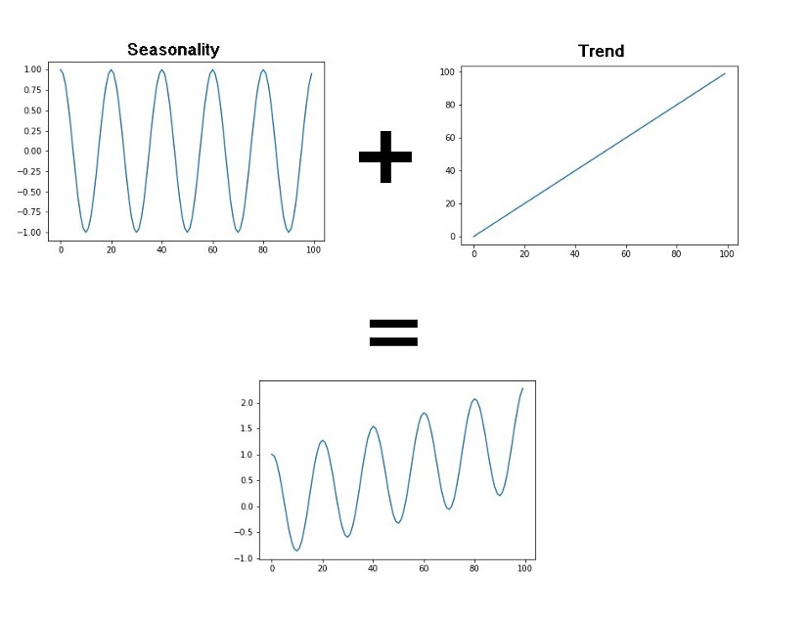We can even think of our basic cosine model from earlier as an additive model with a constant trend! We can model additive time series using the following simple equation:*

*Y[t] = T[t] + S[t] + e[t]*

*Y[t]: Our time-series function*

*T[t]: Trend (general tendency to move up or down)*

*S[t]: Seasonality (cyclic pattern occurring at regular intervals)*

*e[t]: Residual (random noise in the data that isn’t accounted for in the trend or seasonality*

## ***Multiplicative Seasonality***

*The other type of seasonality that you may encounter in your time-series data is multiplicative. In this type, the amplitude of our seasonality becomes larger or smaller based on the trend. An example of multiplicative seasonality is given below.*

*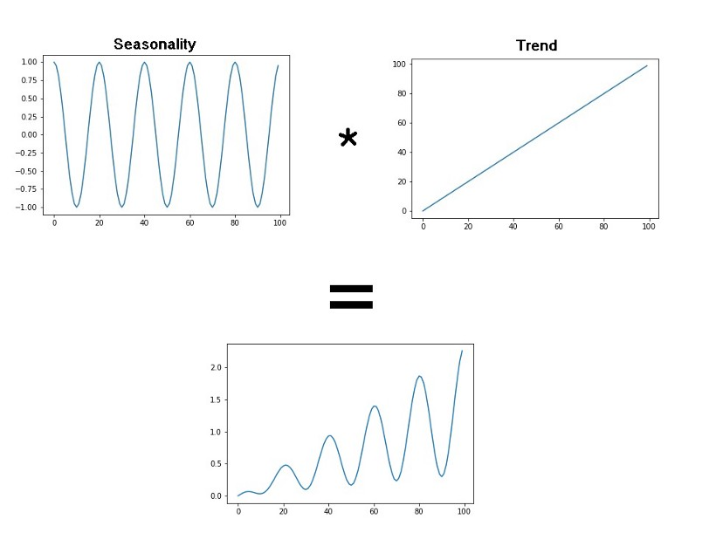We can model this with a similar equation as our additive model by just swapping the additions for multiplications.*

*Y[t] = T[t] *S[t] *e[t]*

| *from statsmodels.tsa.seasonal import seasonal_decompose* |  |
| --- | --- |
|  |  |
|  | *data_orig.set_index('Date', inplace=True)* |
|  |  |
|  | *analysis = data_orig[['Montreal_Median_Price']].copy()* |
|  |  |
|  |  |
|  | *decompose_result_mult = seasonal_decompose(analysis, model="multiplicative")* |
|  |  |
|  | *trend = decompose_result_mult.trend* |
|  | *seasonal = decompose_result_mult.seasonal* |
|  | *residual = decompose_result_mult.resid* |
|  |  |
|  | *decompose_result_mult.plot();* |

# ***How to Create an ARIMA Model for Time Series Forecasting in Python***

*The property of translational equivariance is achieved in CNN’s by the concept of weight sharing. As the same weights are shared across the images, hence if an object occurs in any image it will be detected irrespective of its position in the image. This property is very useful for applications such as image classification, object detection, etc where there may be multiple occurrences of the object or the object might be in motion.*

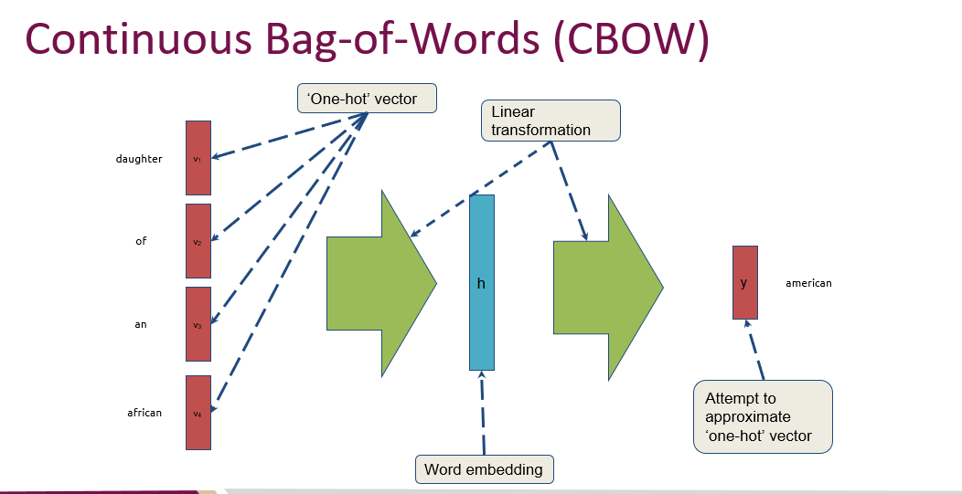

<https://stanford.edu/~shervine/teaching/cs-230/cheatsheet-recurrent-neural-networks>

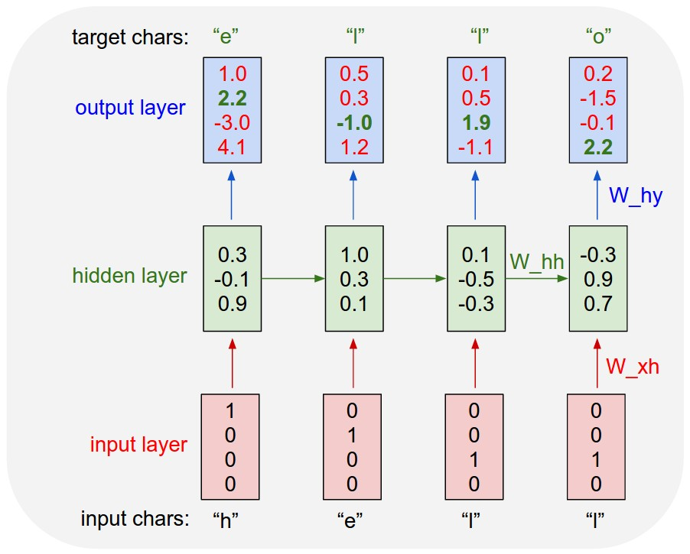

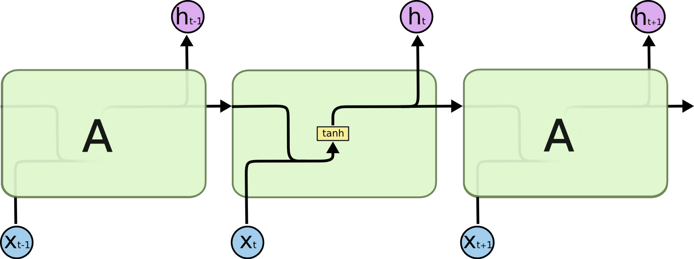

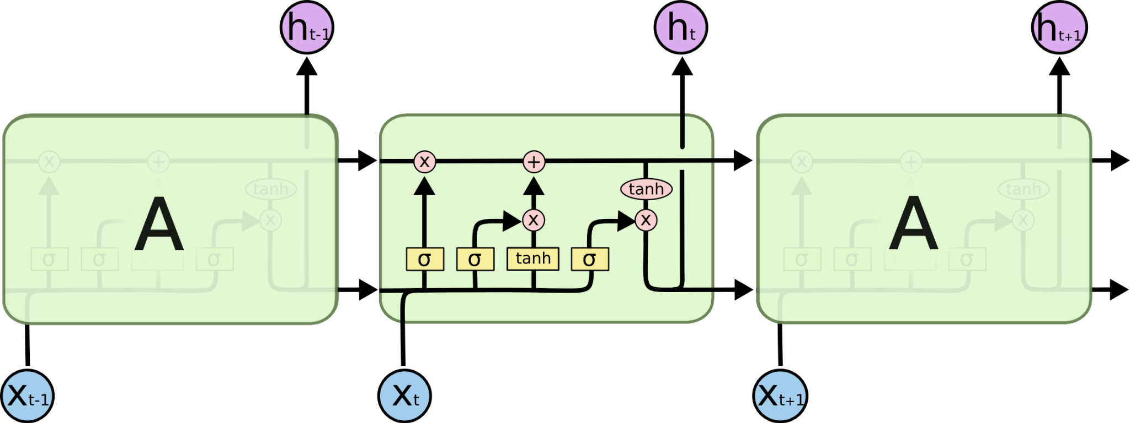

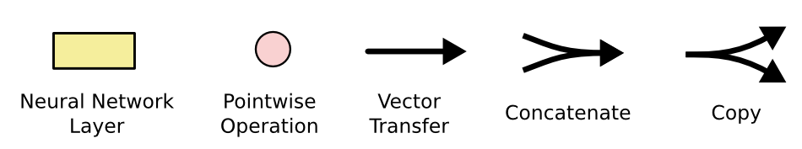

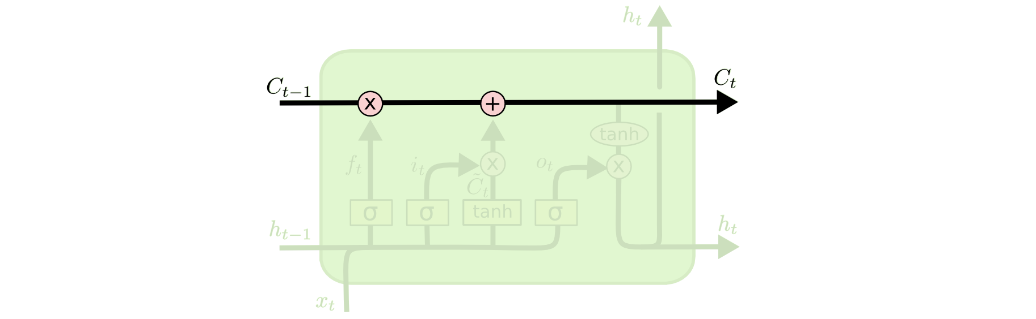

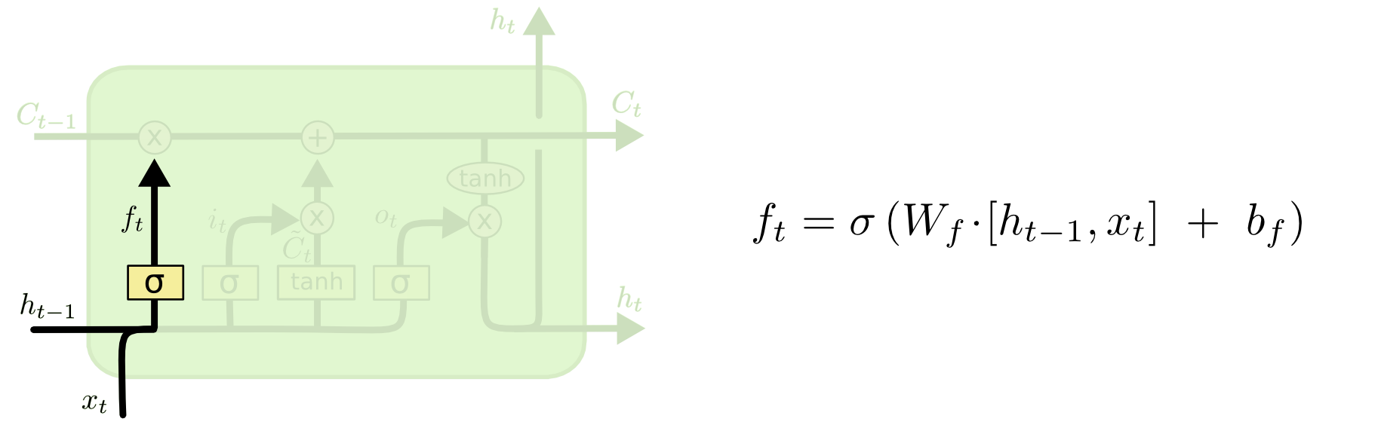

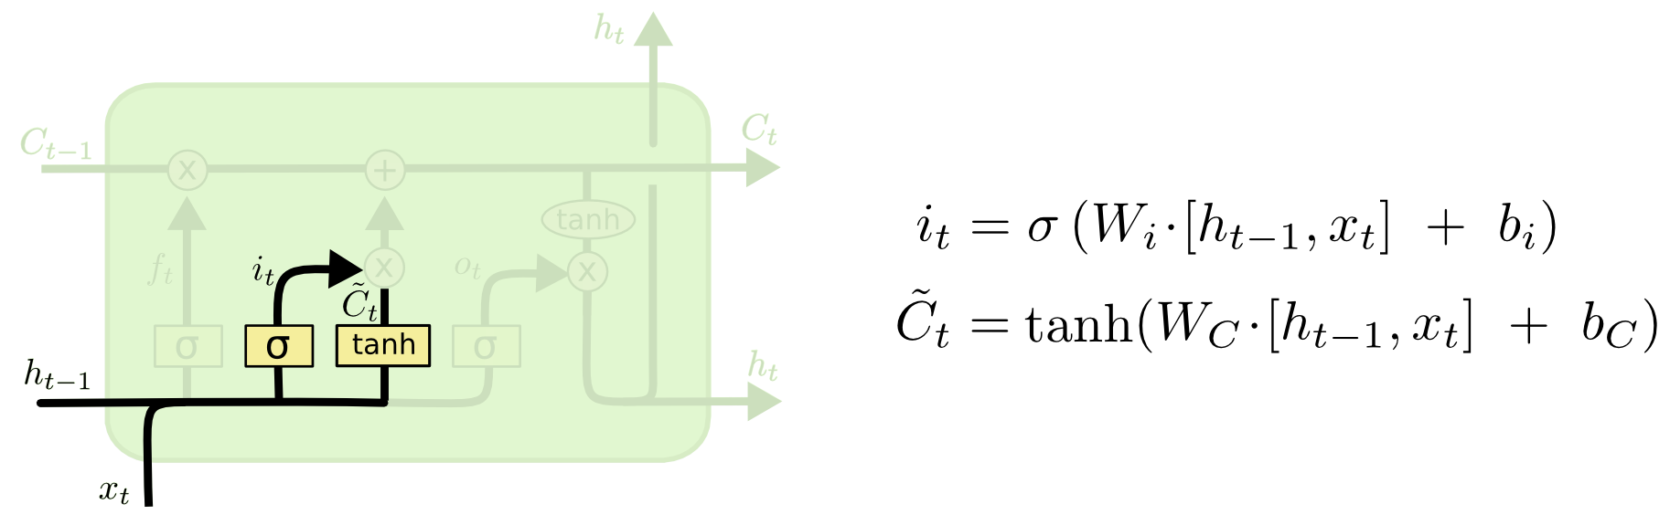

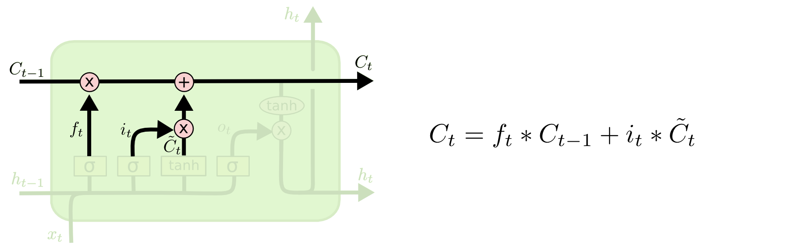

\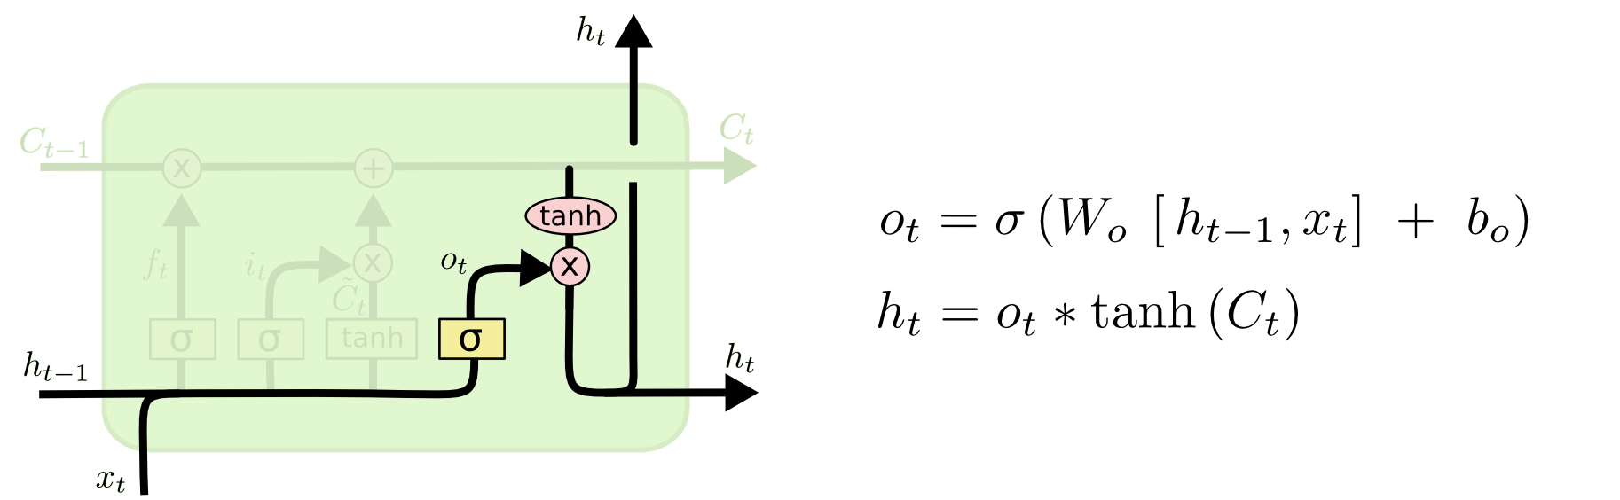

<http://colah.github.io/posts/2015-08-Understanding-LSTMs/>

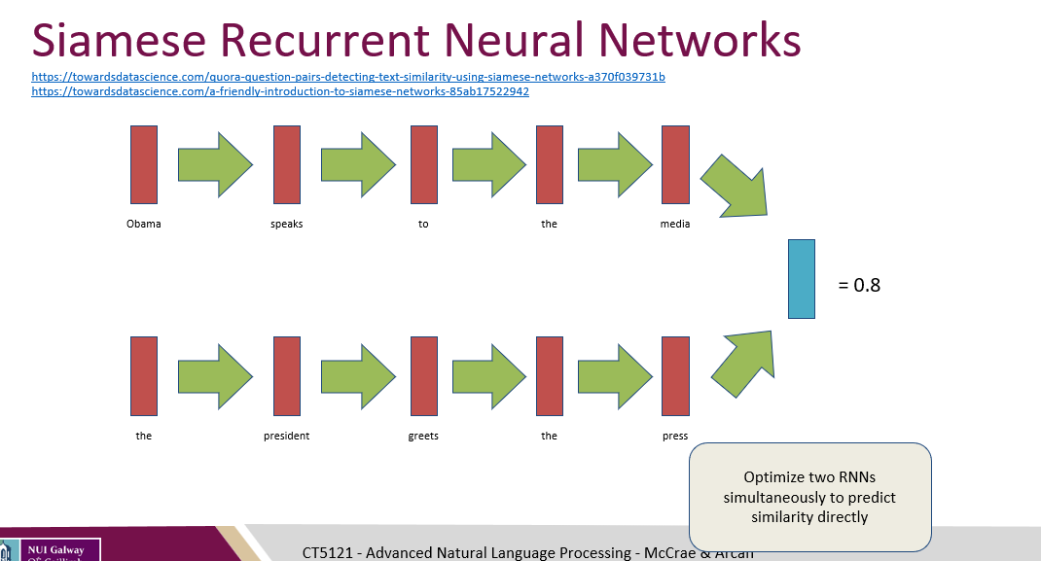

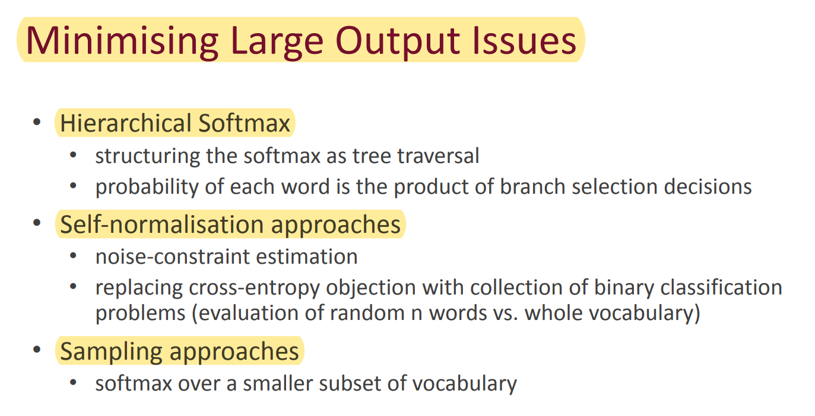

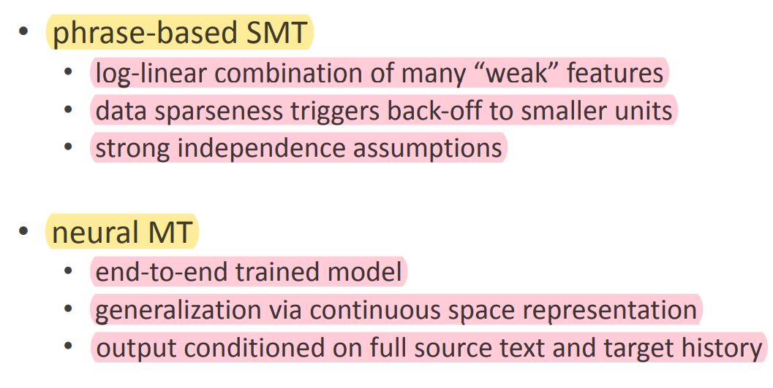

Measuring Agreement between Evaluators • Existing Measures: • Cohen’s Kappa (Cohen, 1960) • Fleiss’s Kappa (Fleiss, 1971) • Scott’s π (Scott, 1955) • Krippendorff’s α (Krippendorff, 1980)

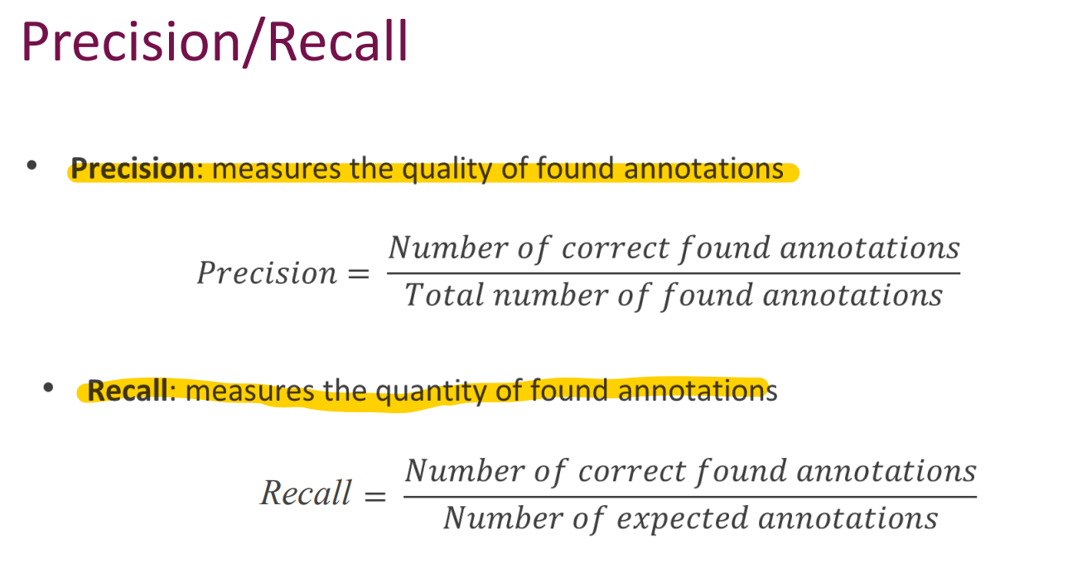

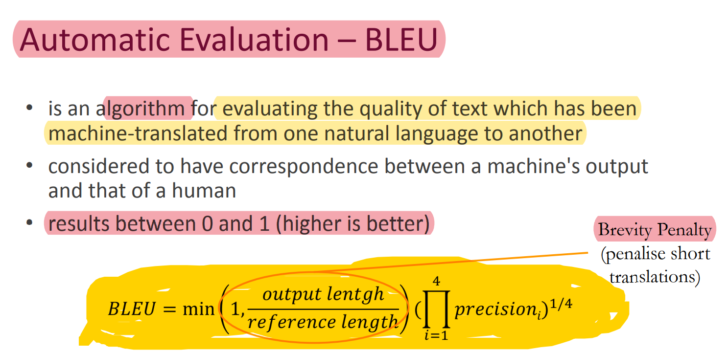

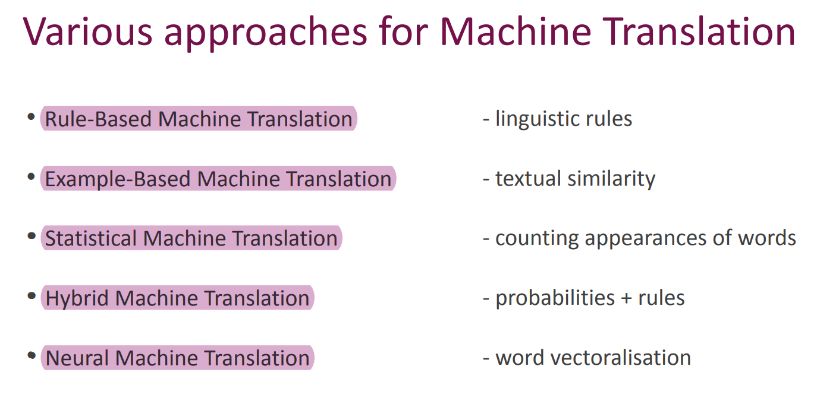

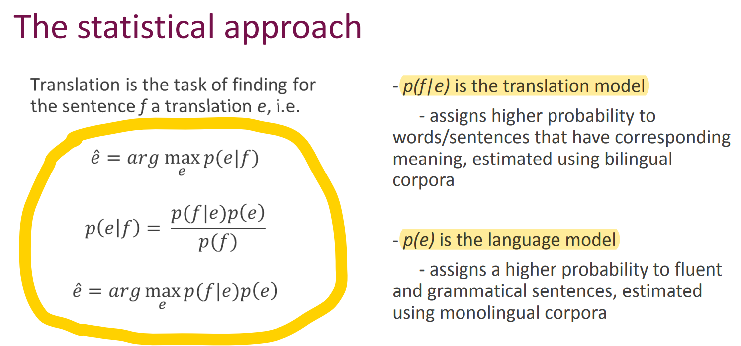

Language Model Smoothing • Add One Smoothing • Deleted Estimation • Interpolation / recursive interpolation • Witten-Bell Smoothing • Kneser-Ney Smoothing • Modified Kneser-Ney Smoothing • Modified Kneser-Ney Smoothing with absolute discounting

def model_final(input_shape, output_sequence_length, english_vocab_size, french_vocab_size):

"""

Build and train a model that incorporates embedding, encoder-decoder, and bidirectional RNN on x and y

:param input_shape: Tuple of input shape

:param output_sequence_length: Length of output sequence

:param english_vocab_size: Number of unique English words in the dataset

:param french_vocab_size: Number of unique French words in the dataset

:return: Keras model built, but not trained

"""

model = Sequential()

model.add(Embedding(input_dim=english_vocab_size,output_dim=128,input_length=input_shape[1]))

model.add(Bidirectional(GRU(256,return_sequences=False)))

model.add(RepeatVector(output_sequence_length))

model.add(Bidirectional(GRU(256,return_sequences=True)))

model.add(TimeDistributed(Dense(french_vocab_size,activation='softmax')))

learning_rate = 0.005

model.compile(loss = sparse_categorical_crossentropy,

optimizer = Adam(learning_rate),

metrics = ['accuracy'])

return model

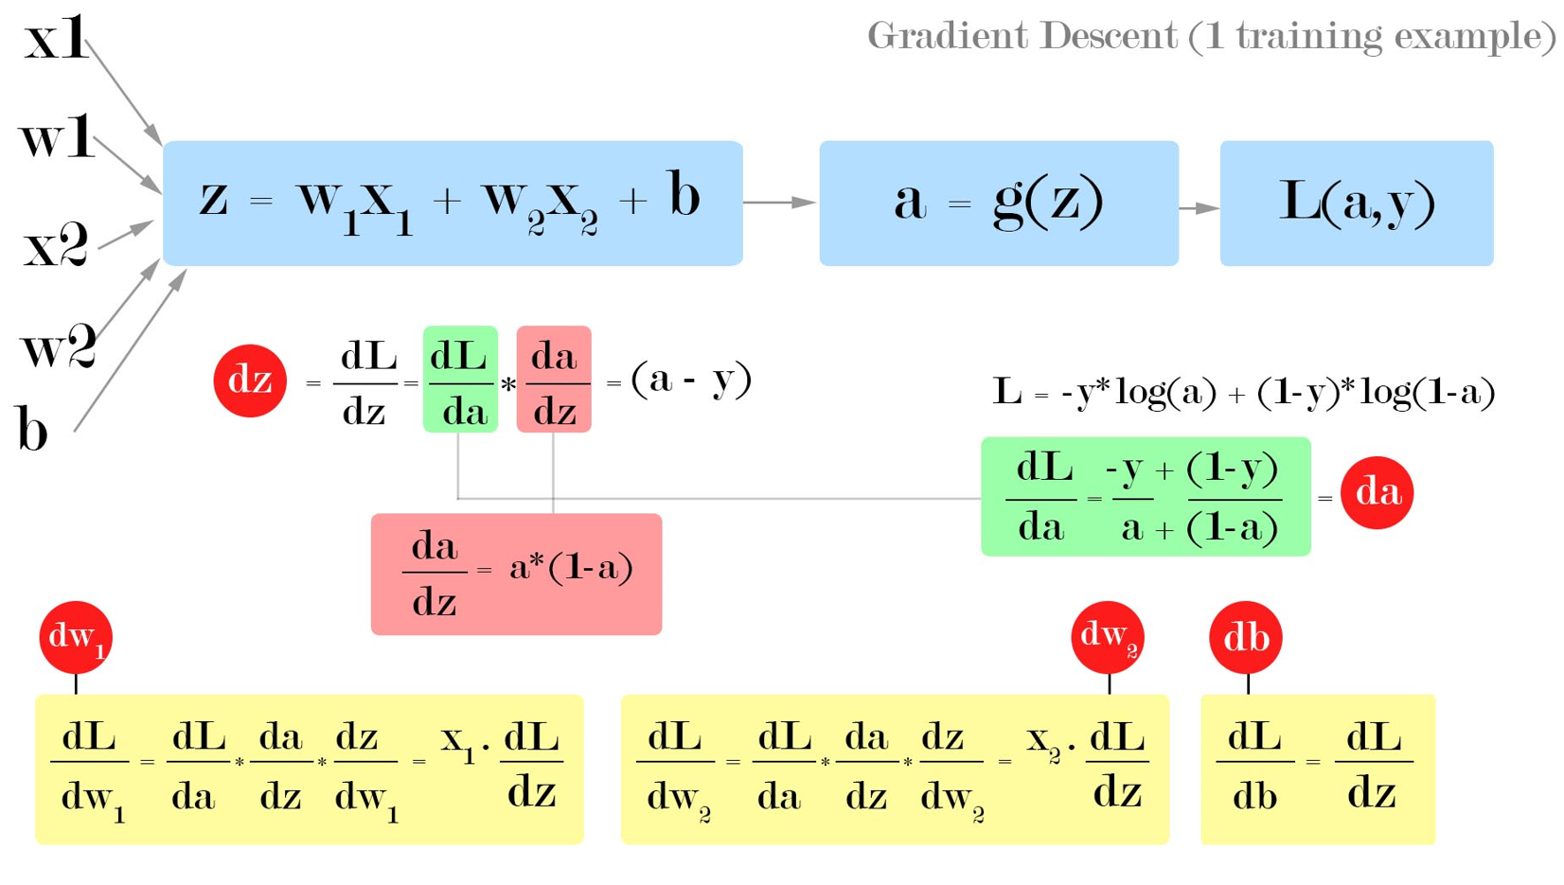

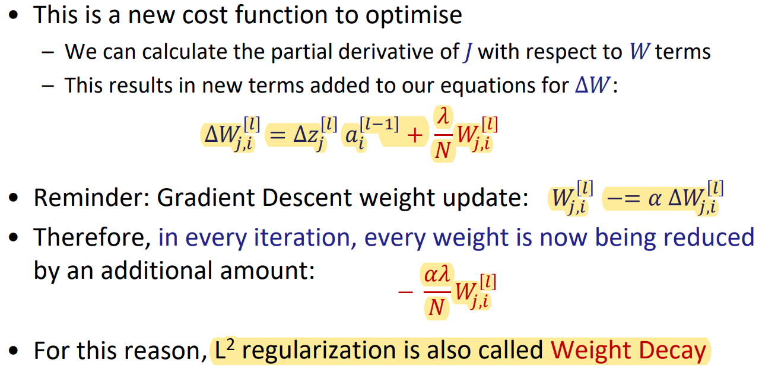

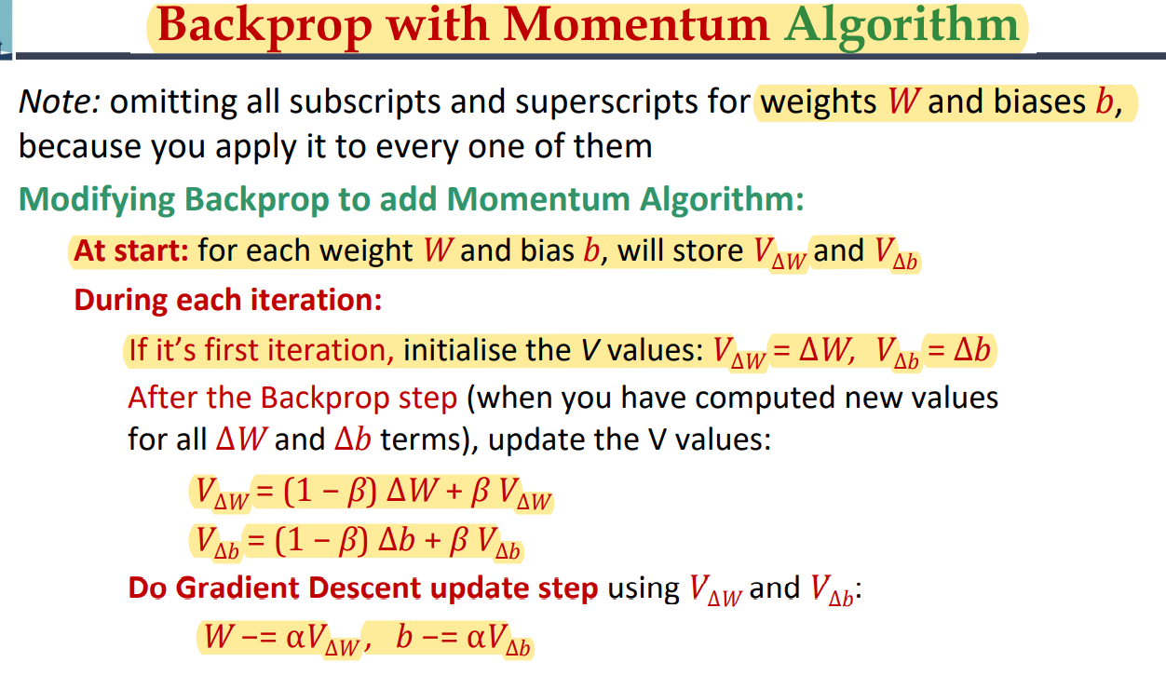

In Backprop with Momentum, if the analogy is that we are calculating “velocity” terms, then in RMSprop we are calculating “acceleration” terms

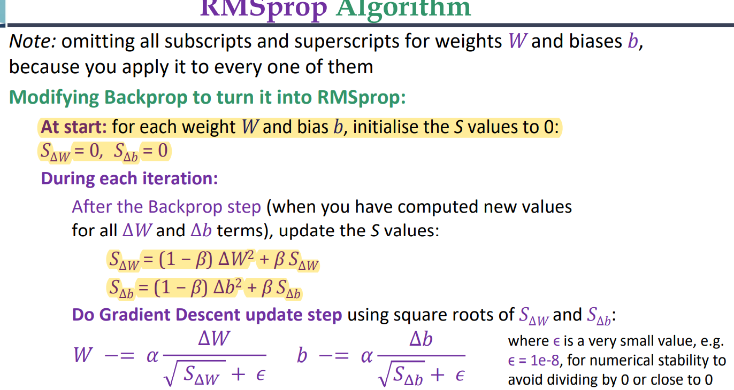

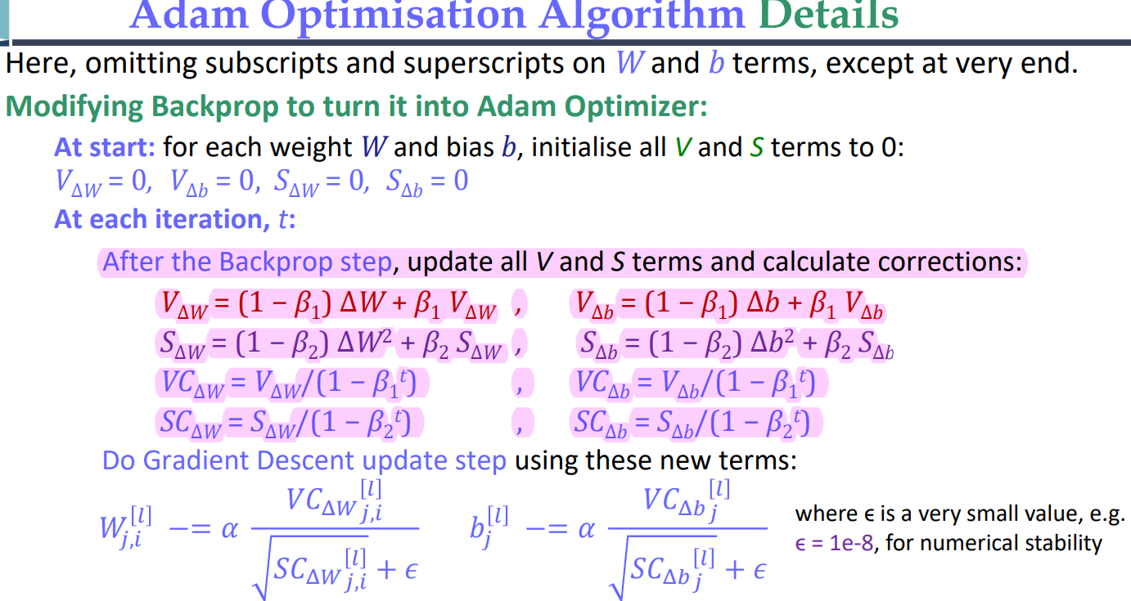

model.compile(loss="categorical_crossentropy" , optimizer="adam" , metrics=["accuracy"])

Alternative way to call model.fit(): model.fit(dataset, batch_size=batch_size, epochs=epochs, validation_data=val_dataset)

– Import – Load data – Create model: e.g. model = models.Sequential([ ... ]) – Compile: model.compile() # loss function, optimizer, metrics – Fit: model.fit() # dataset, callbacks – Evaluate: model.evaluate(X_new) – Predict: yhat = model.predict(X)

Suppose layer 𝐿 has learned a useful transformation to apply to its input data – But because of training, layer 𝐿 − 1 now outputs a different distribution to layer 𝐿 – Some of layer 𝐿’s transformation becomes useless. – This happens all the time – Even small changes in early layers have large effects on distribution in deep layers

Triplet loss

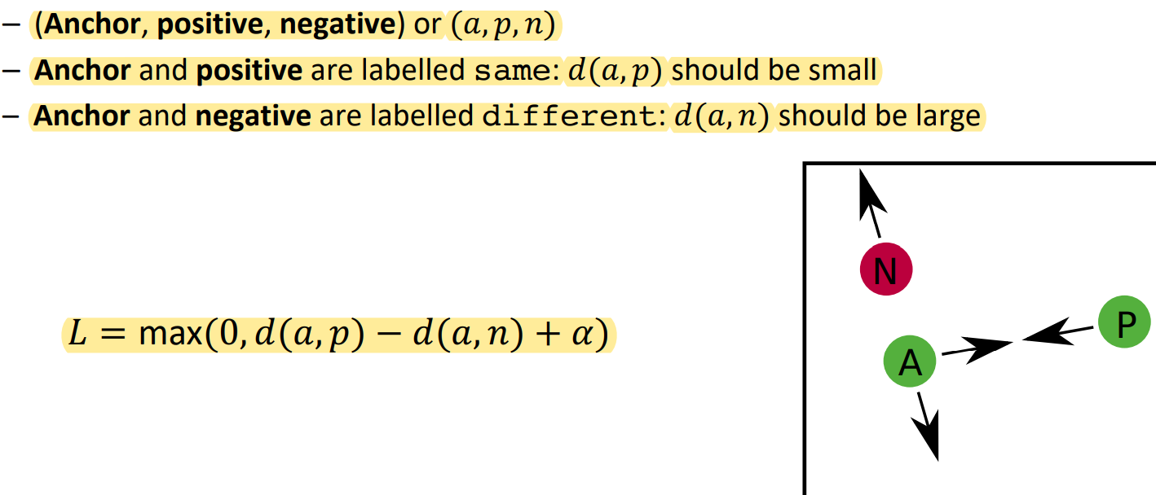

A common architecture is called DCGAN (deep convolutional GAN). Although most GANs are indeed deep and convolutional, the term DCGAN refers to a specific architecture: – Convolutional discriminator – Convolutional generator with “deconvolution” – LeakyReLU activations – BatchNorm – RMSprop optimizer – Label smoothing/noise

**Optimization**

Enumerative search

Random search

def rand_search(X, f, its=10000): return max(random.sample(X, its), key=f)

Hill climbing

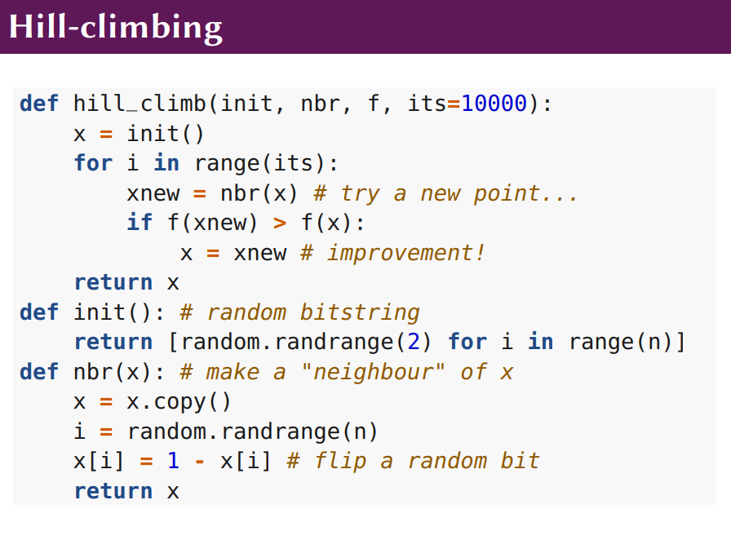

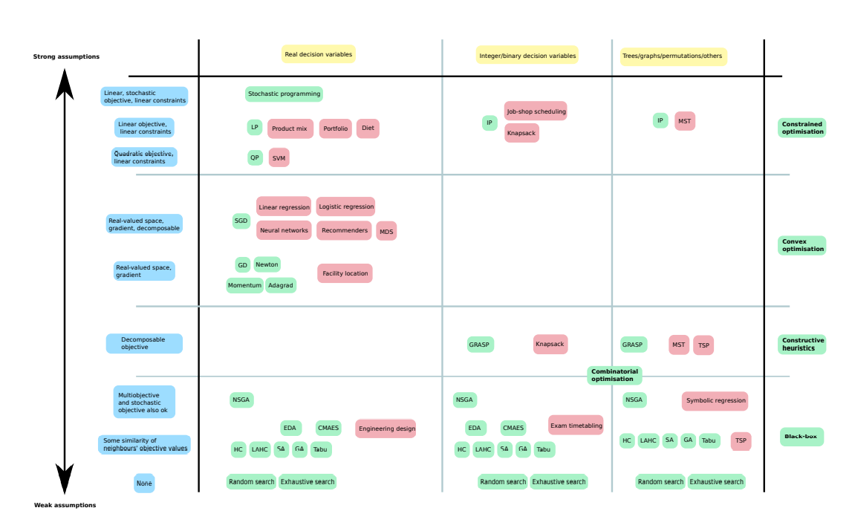

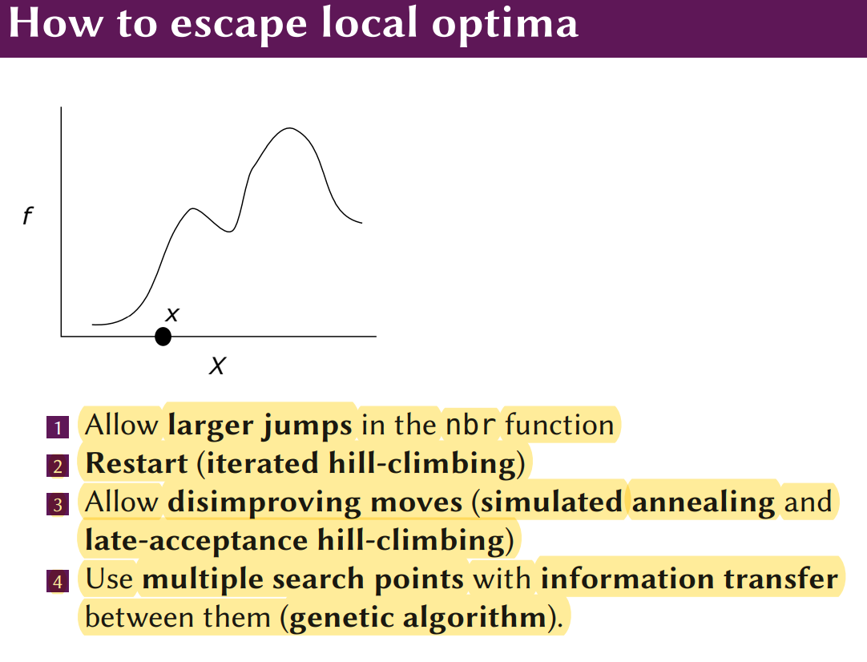

Simulated annealing is a variant of hill-climbing where we sometimes accept disimproving moves, i.e. x := x 0 even though x 0 is worse!

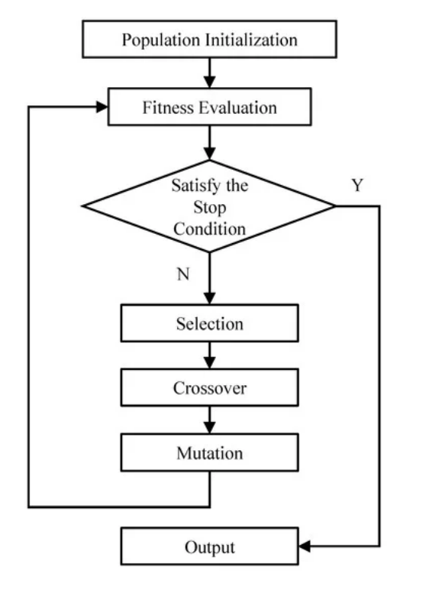

def tournament_select(pop, popfit, size):

# To avoid re-calculating f for same individual multiple times, we

# put fitness evaluation in the main loop and store the result in

# popfit. We pass that in here. Now the candidates are just

# indices, representing individuals in the population.

candidates = random.sample(list(range(len(pop))), size)

# The winner is the index of the individual with min fitness.

winner = min(candidates, key=lambda c: popfit[c])

return pop[winner]

scipy.optimize.minimize(fun, x0, args=(), method=None, jac=None, hess=None, hessp=None, bounds=None, constraints=(), tol=None, callback=None, options=None)

Scalability Landscapes: local optima, problem diiculty Exploration and exploitation Hyperparameters Metaphors How much information does the objective give us? Choice of algorithm for the problem6

Functional programming-style solutions are usually the better approach • Immutability • Side-effect-free functions: functions don't interfere with each other • No global mutable state • Avoidance of resource sharing

The Apache Spark programming model makes heavy use of higher-order functions

Later, such interface are also used for determining the type of -> lambda expressions

Lambda expressions are anonymous functions (functions without names)

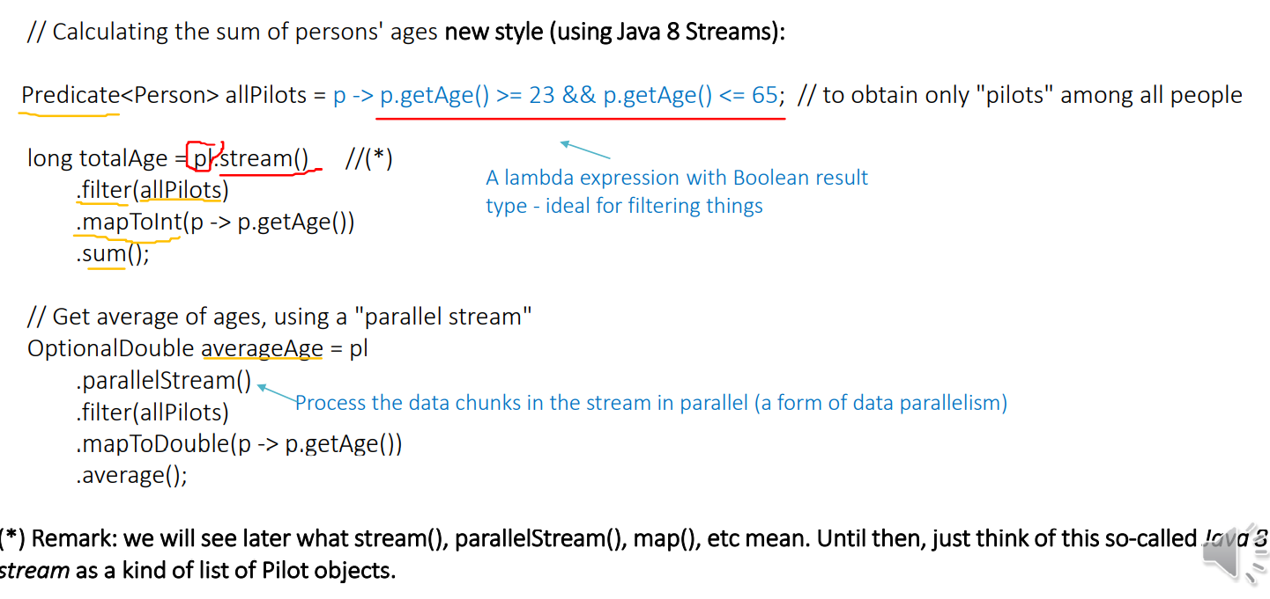

personsList .stream() .filter(allPilots) .mapToInt(p -> p.getAge()) .sum();

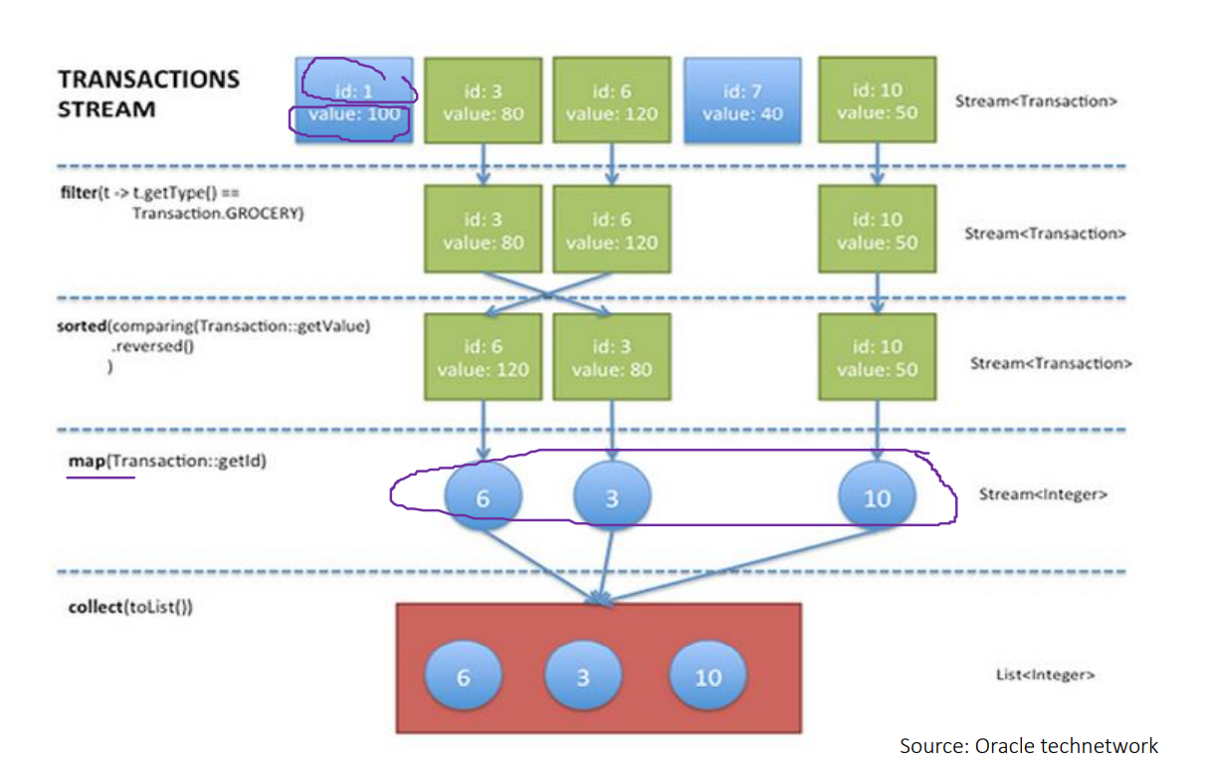

MAP REDUCE

map maps each input (inKey, inValue)-pair to a list of (outKey, intermediateValue)- pairs.

A built-in shuffle operation (provided by the MapReduce framework) groups all (outKey, intermediateValue)-pairs by their outKeys and transfers them to different machines (where they will be reduced in the next step). Which machine to send the intermediate data to is determined by the respective outKey! • That is, shuffle essentially exchanges intermediate data among several machines, via a network (typically a LAN)

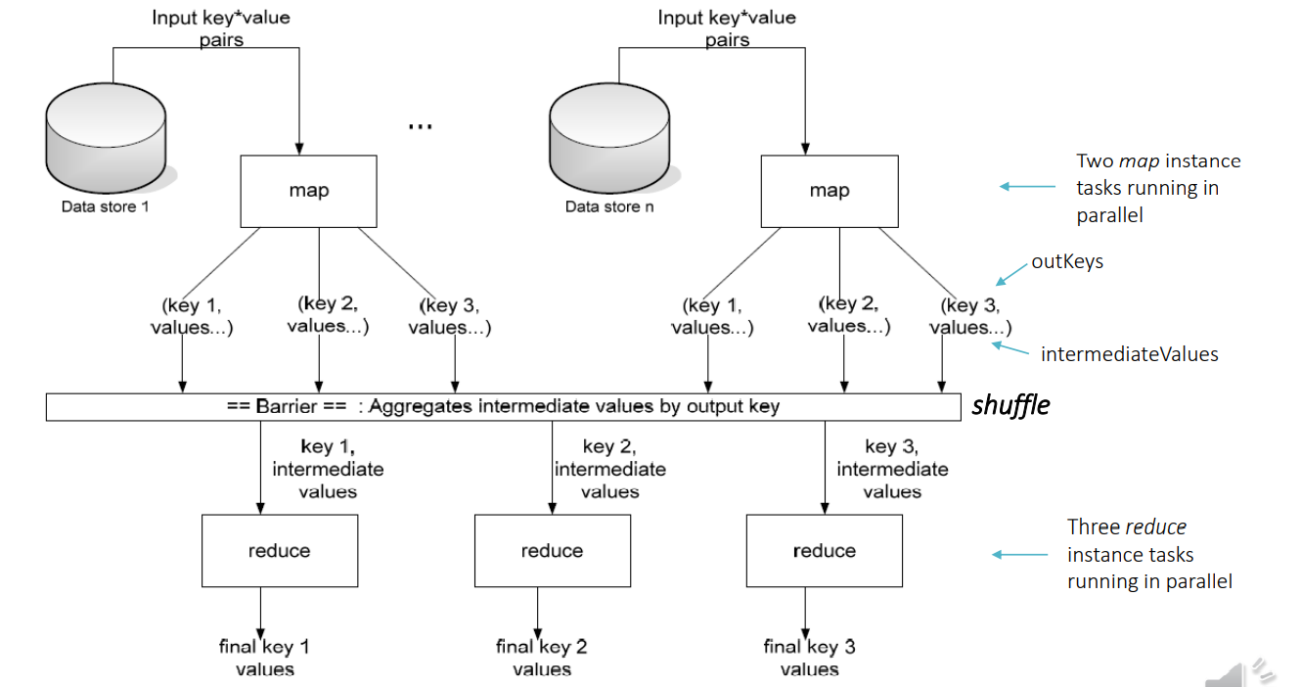

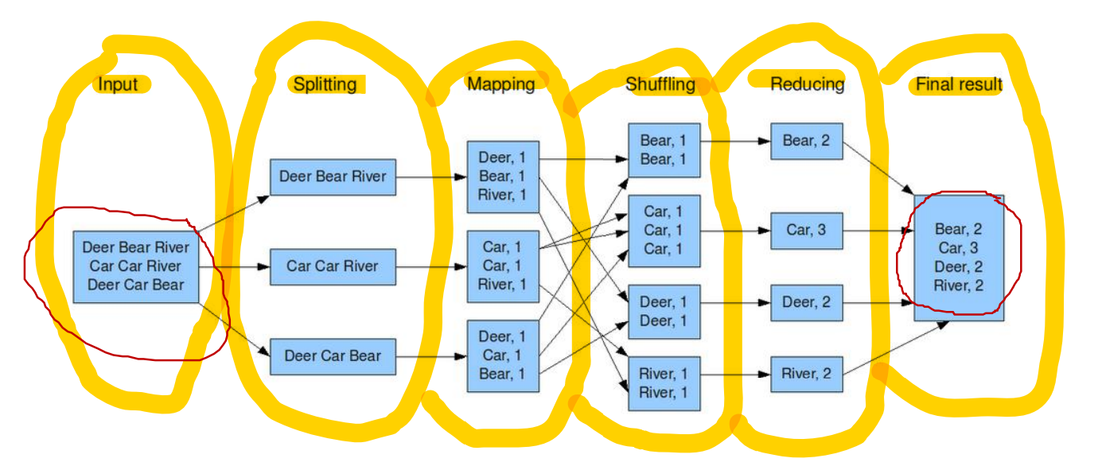

In Java 8, we can emulate shuffling using, e.g., groupingBy or reduce stream operations, however, this misses of course the crucial aspect of distributing values onto different machines in the cluster

"Locality" refers to several criteria: 1) Physical proximity of data and computations and minimization of communication and sharing 2) Avoidance of global/cross-function side effects of individual map (or reduce) computations, in order to be able to perform them in parallel

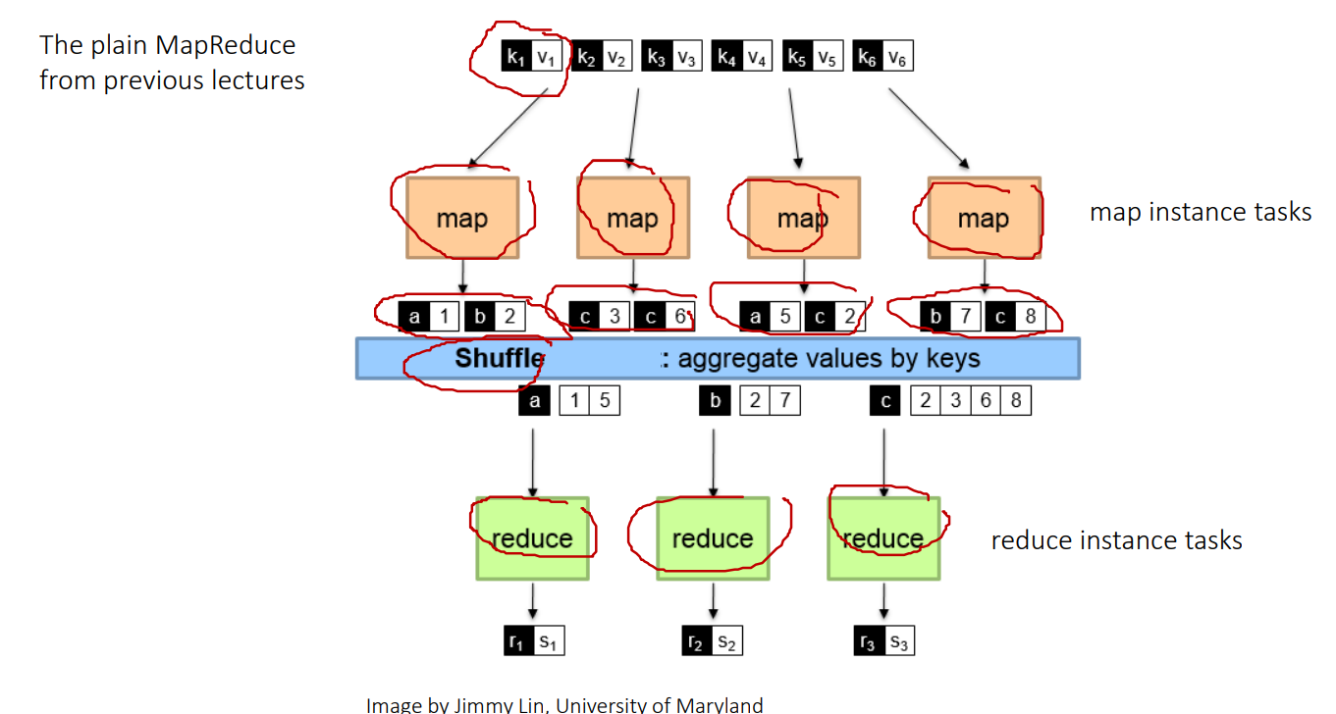

• Hadoop/MapReduce • Fault-tolerance • Scheduling of execution tasks • Execution

• HDFS • Fault-tolerance • High-bandwidth • High availability

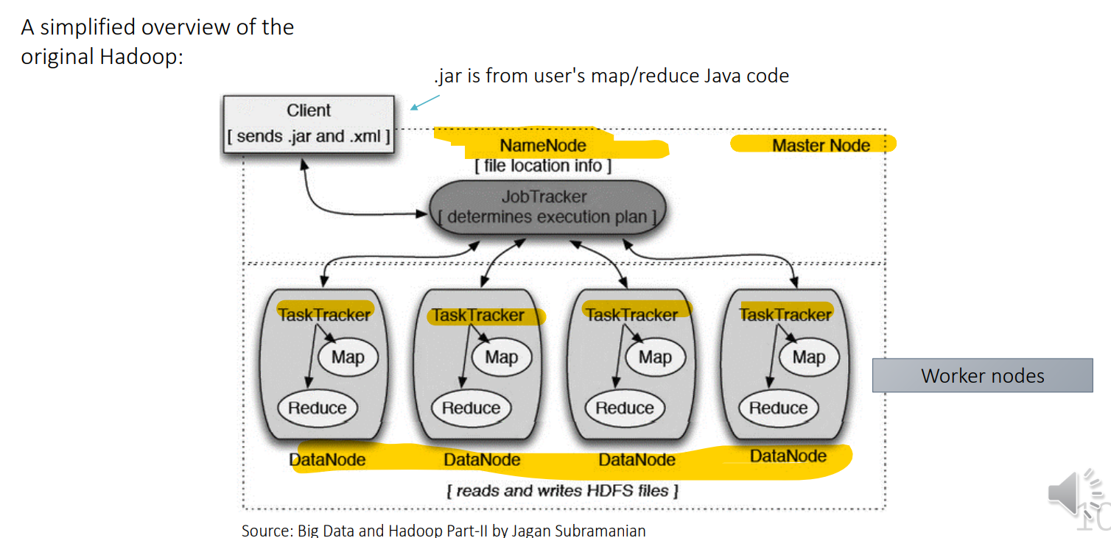

• Worker nodes do so by employing data nodes and task trackers • A data node stores the data, that is, the (key, value)-pairs

• Distributed computing across several machines/nodes • Parallel processing within a single machine/node

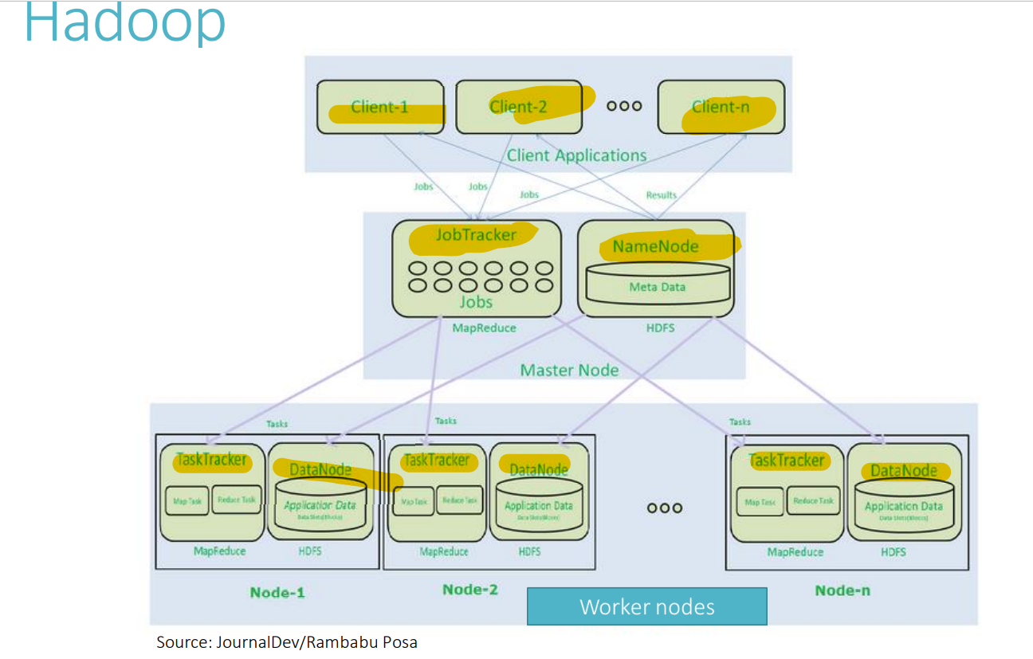

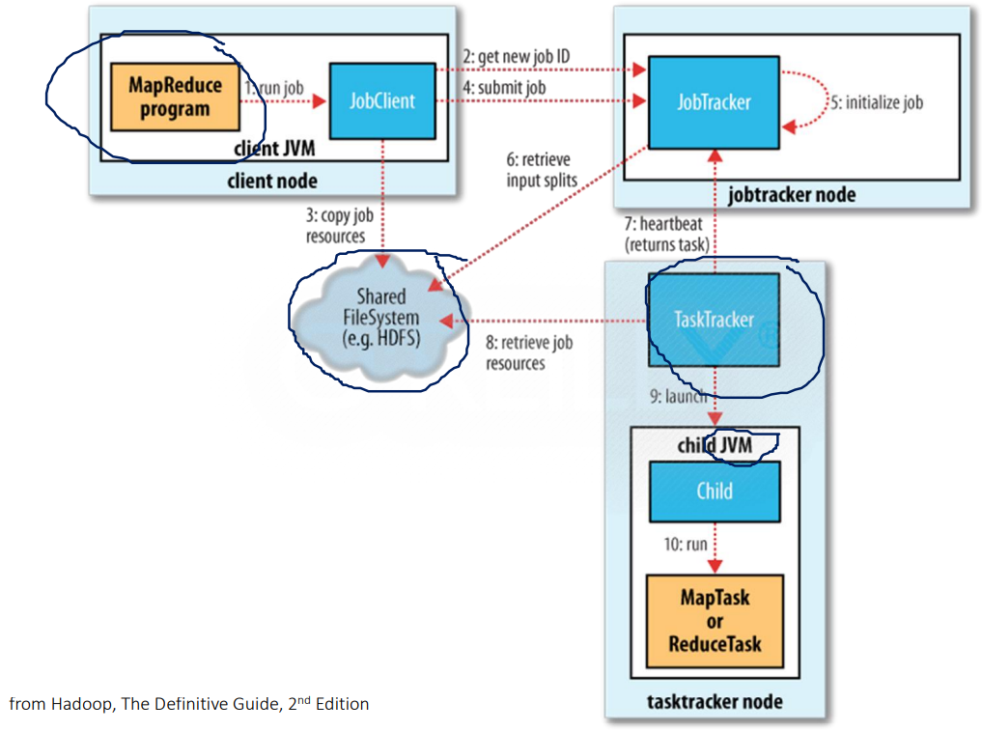

| public Double maxTemperature(int startTime,int endTime) throws NoSuchElementException{ |  |
| --- | --- |
|  | /* |
|  | Solution for part 1 : This function returns the max temperature recorded by this whether station |
|  | between the range of startTime and endTime |
|  | */ |
|  | Double maxTemperature = measurements.stream() |
|  | .filter( m -> m.getTime() >= startTime && m.getTime() <= endTime ) // Filter all those measurements whose time in range |
|  | .mapToDouble( m -> m.getTemperature() ) // map all measurements to their respective temperature |
|  | .max().orElseThrow( NoSuchElementException::new ); // find the max temperature |
|  | return maxTemperature; |
|  | } |

Basic distributed data structures: • RDDs (from first version until now): easy to use, intuitive, stable and flexible - but not the most efficient, i.a. due to large overhead for serialization) • DataFrame (since Spark 1.3): fast, stable, close to SQL (not natural to use for non-SQL experts), restricted expressiveness compared to RDDs, works best with Scala • Datasets (since Spark 1.6 as a preview, fully supported since Spark 2.0): sort of mix between RDDs and DataFrames, fast but not fully stable yet

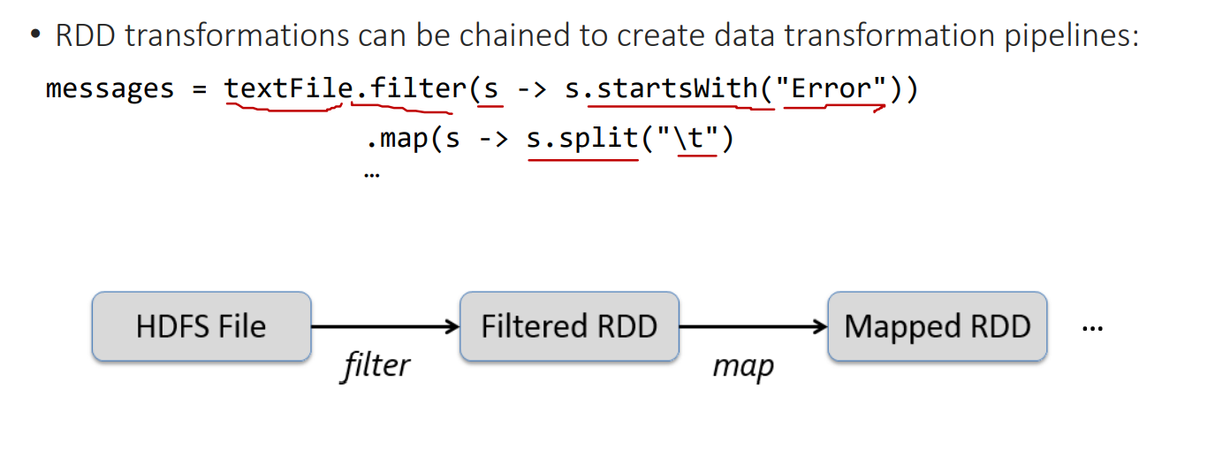

RDDs also include a facility to increase fault tolerance

The most important RDD transformations which operate on key-value pairs: reduceByKey and groupByKey

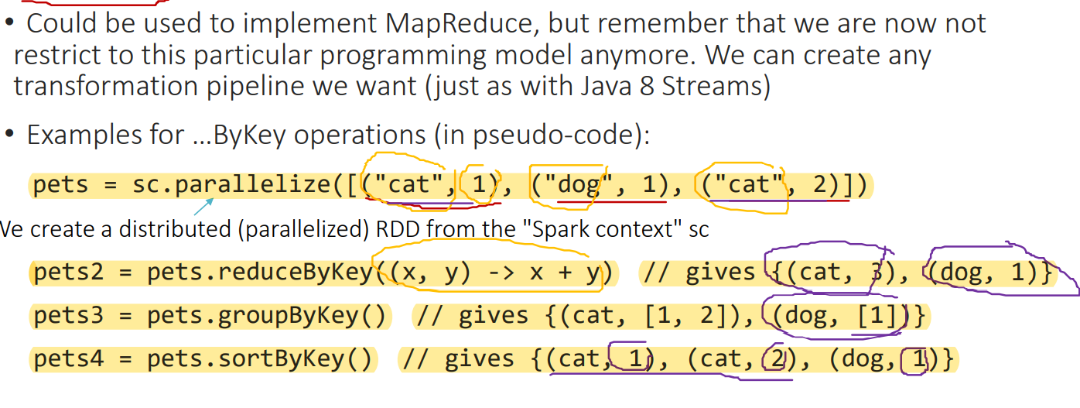

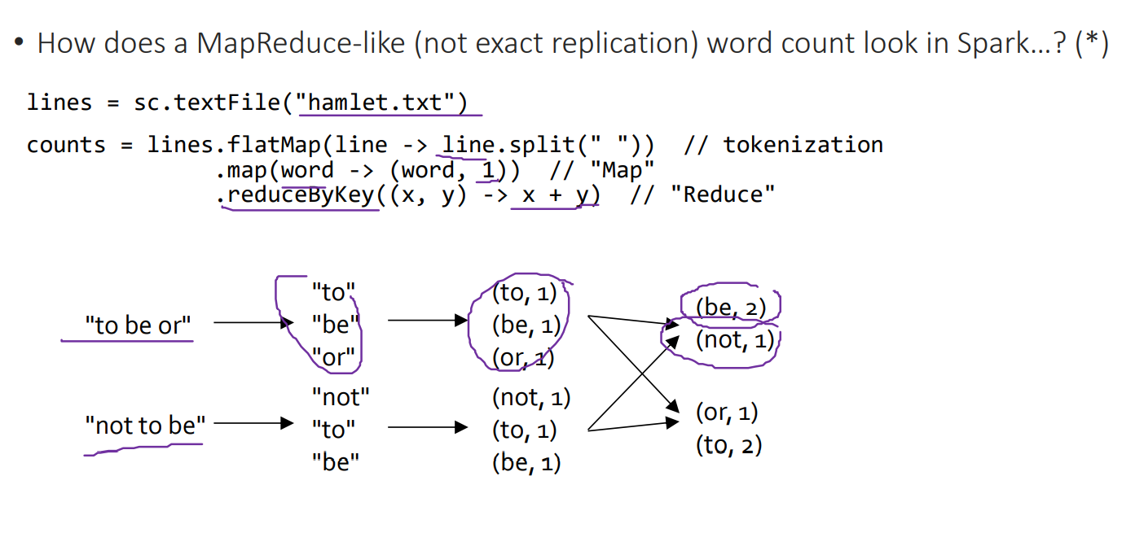

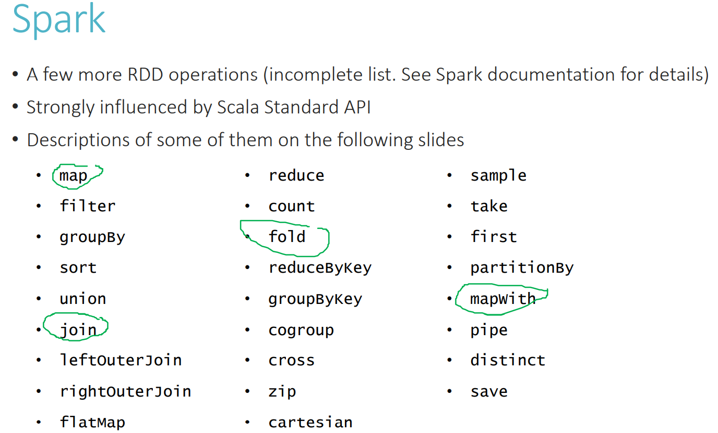

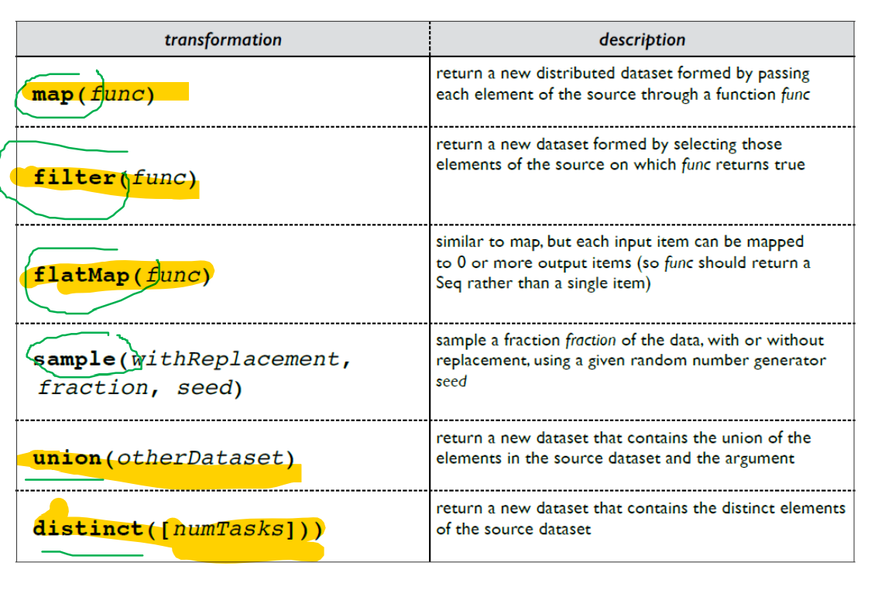

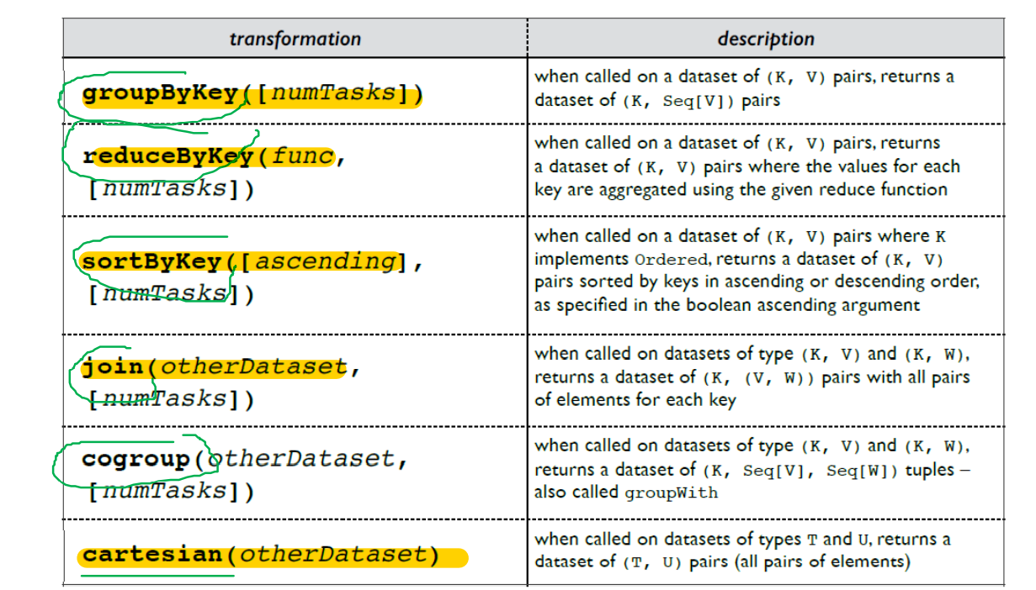

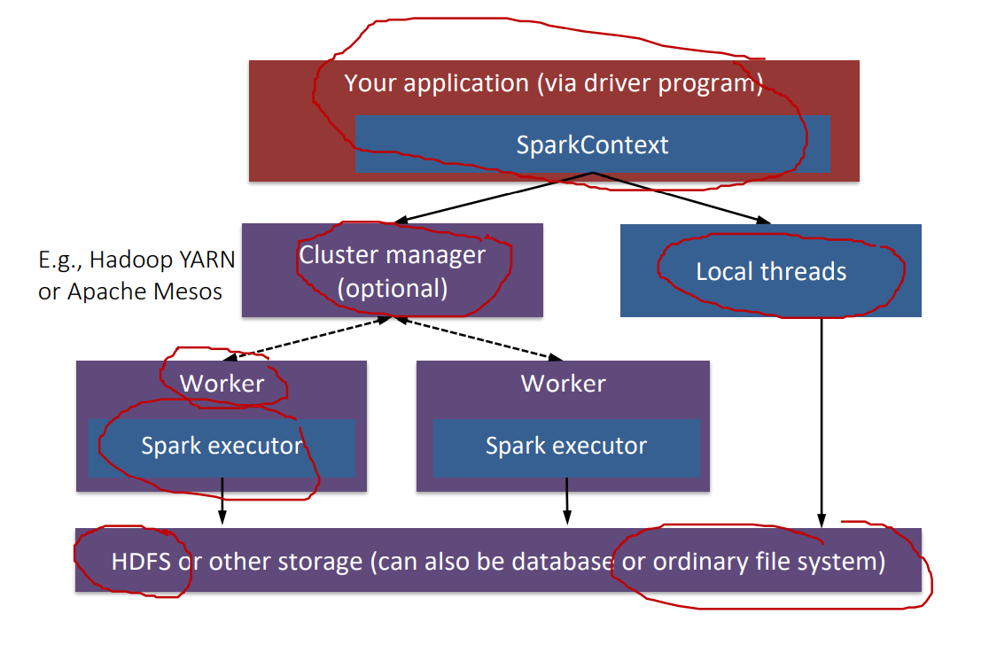

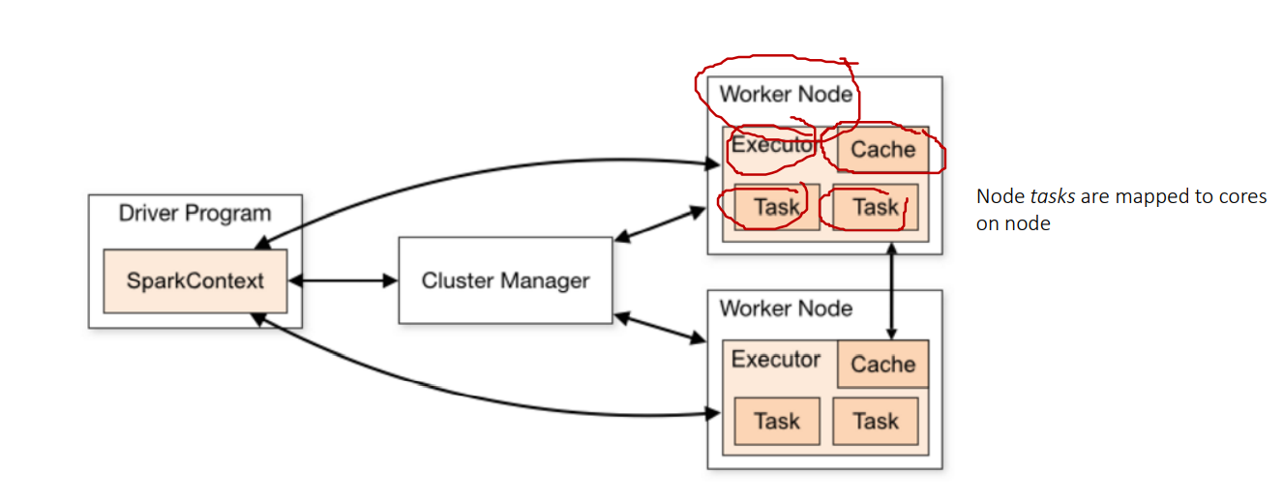

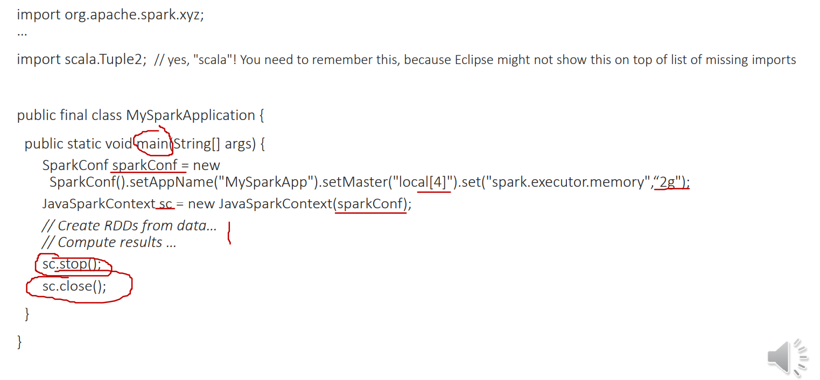

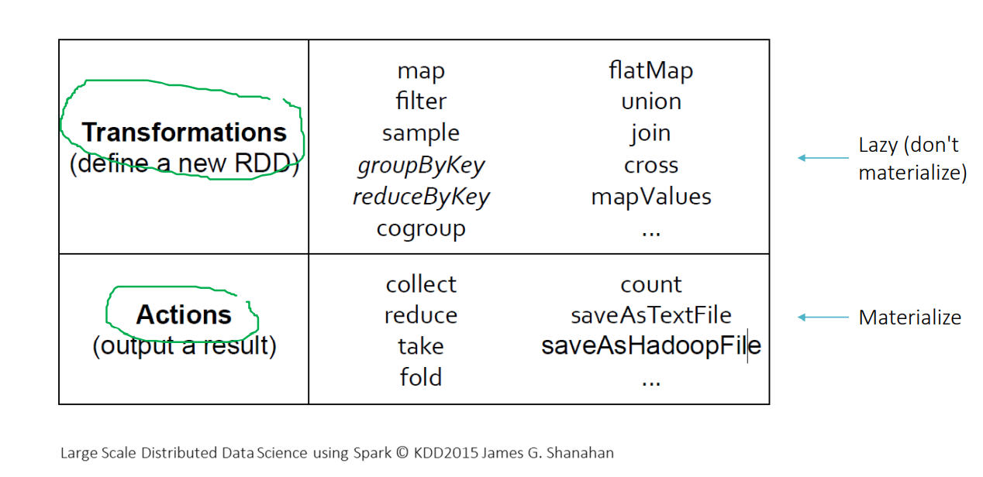

• Packages • spark.mllib (core ML library, based on RDDs) • spark.ml (newer, based on DataFrames and Spark ML Pipelines – covered in one of our next lectures)

• Packages • spark.mllib (core ML library, based on RDDs) • spark.ml (newer, based on DataFrames and Spark ML Pipelines – covered in one of our next lectures)

Datasets are not available for Python and R. However, DataFrame <=> Dataset with untyped rows,

df.filter(df.col("age").gt(20)).show();

DataFrame cheapBooks = sqlContext.sql("SELECT book FROM books WHERE price <= 10");

// Apply a schema to an RDD of books and register it as a table. // Important: class Book needs to be a JavaBean class (to be suitable as a "schema") // i.e., it must specify field getters and setters, be serializable, be public. DataFrame schematedBooks = sqlContext.createDataFrame(books, Book.class); schematedBooks.registerTempTable("books");

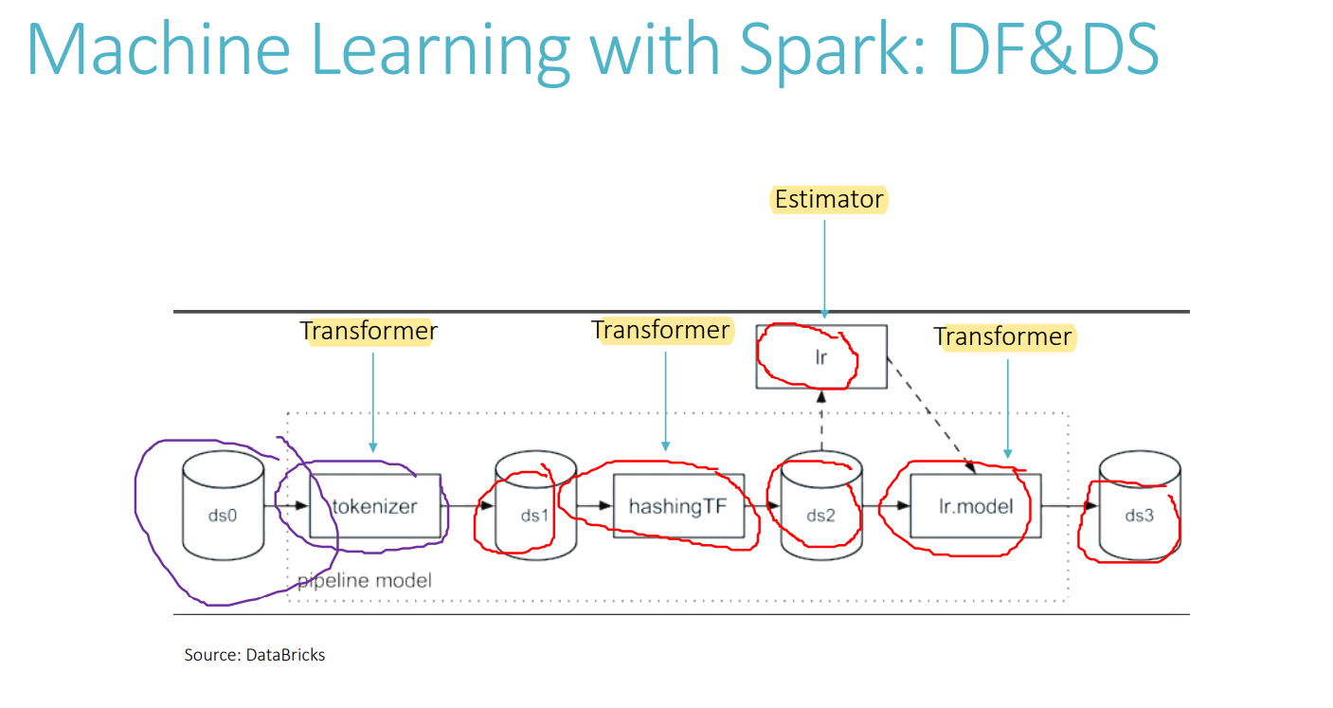

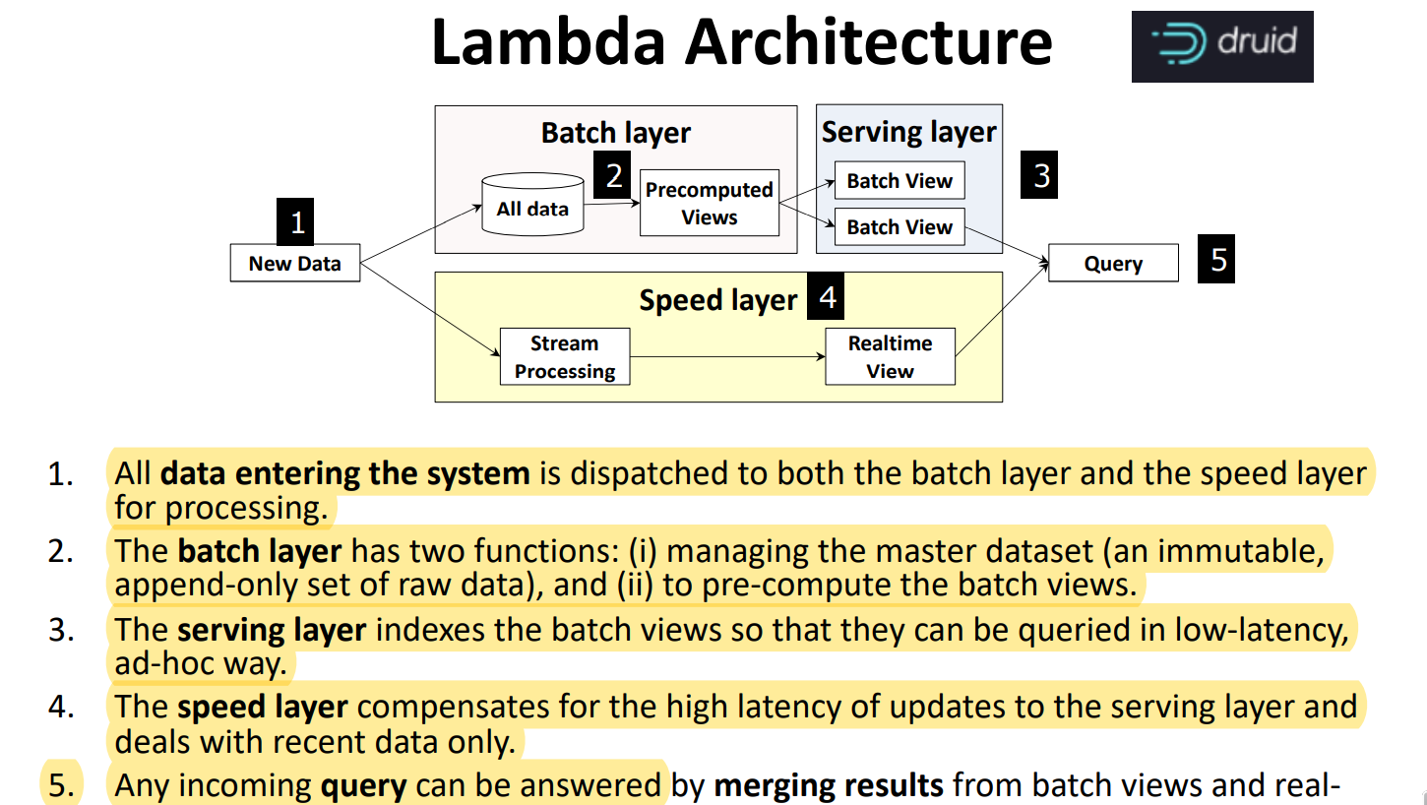

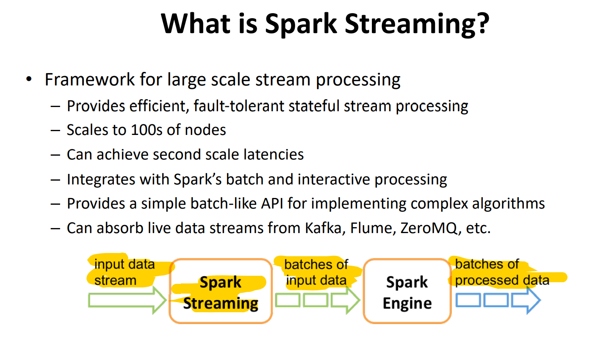

Stream Processing Optimisations • Operator Reordering • Redundancy Elimination • Operator Separation • Fission (Data Parallelism)

Batch Normalization: A trainable approach to normalizing the data by learning scale and shift variable during training.

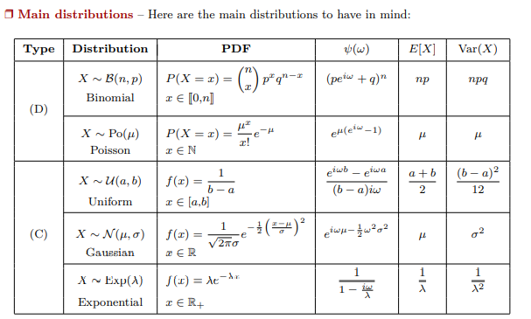

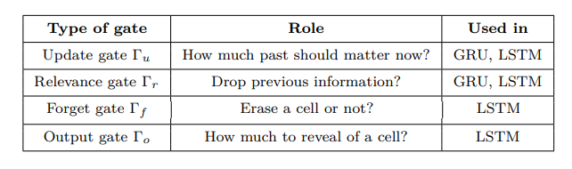

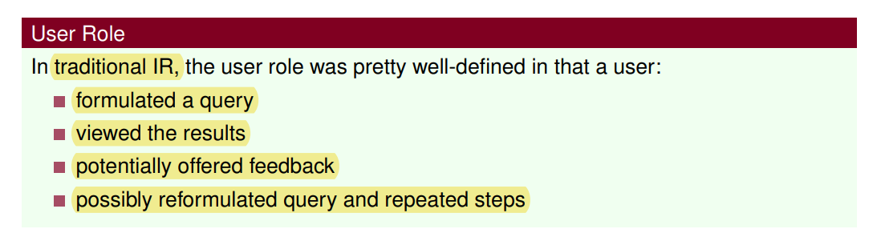

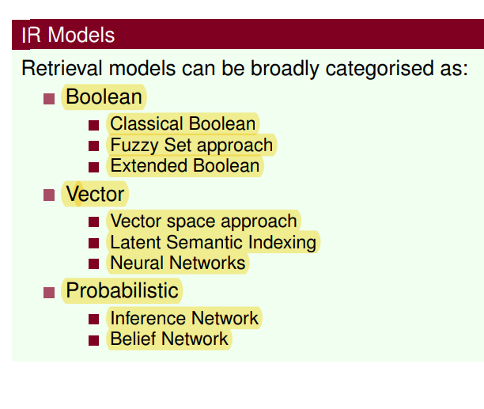

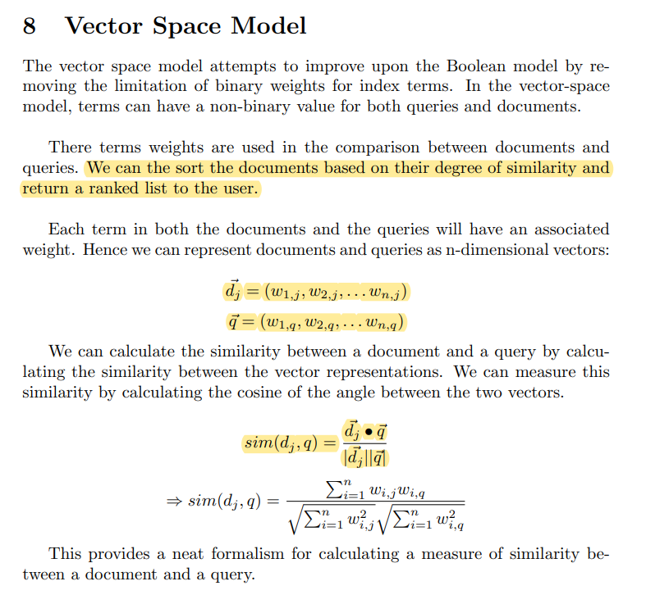

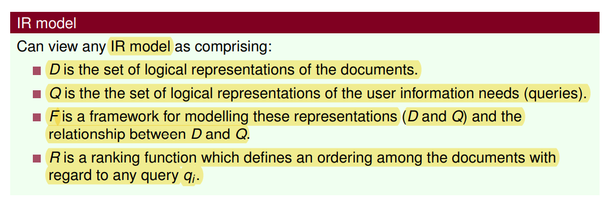

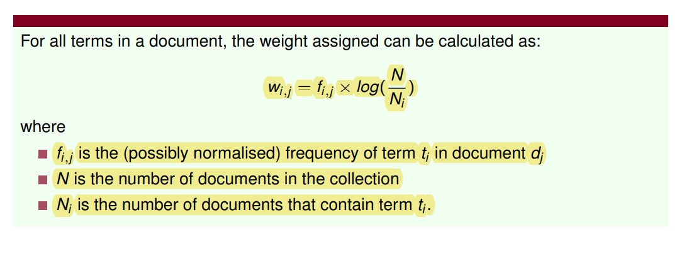

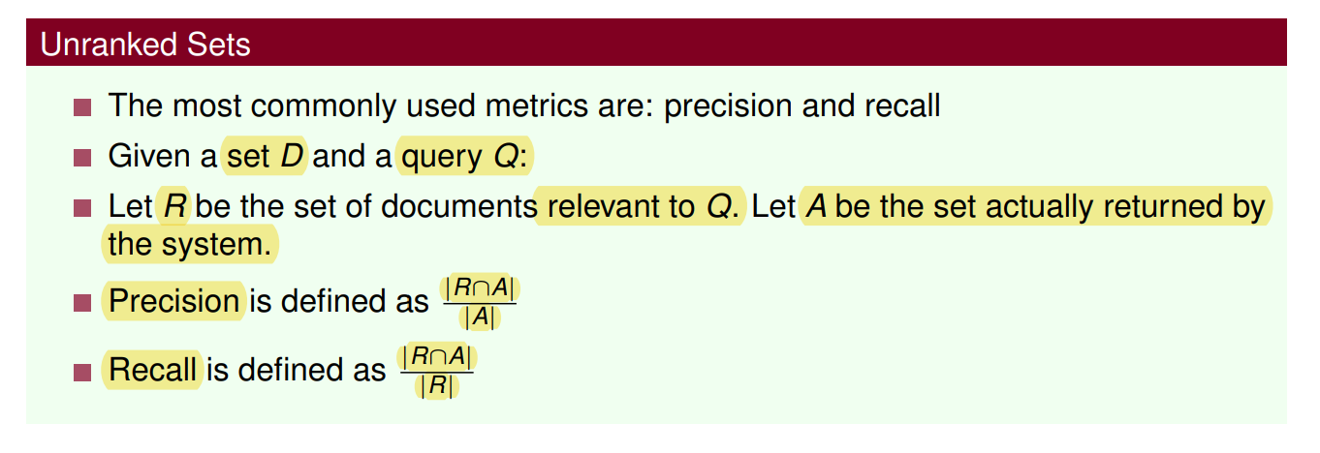

Recall is non-decreasing as the number of documents returned increases. Precision usually decreases as the number of documents returned increases.

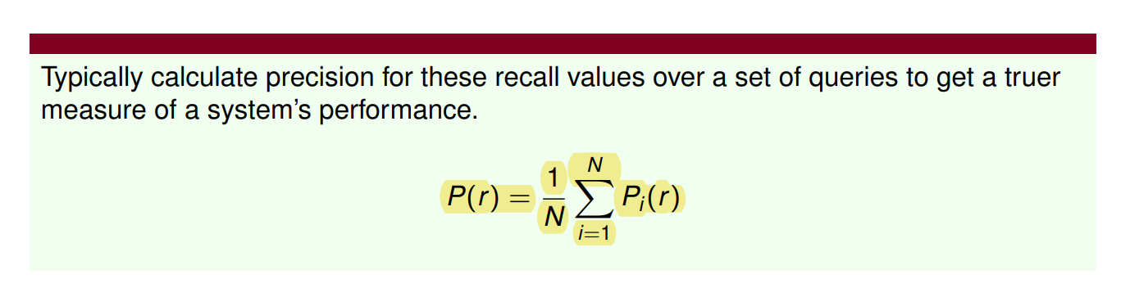

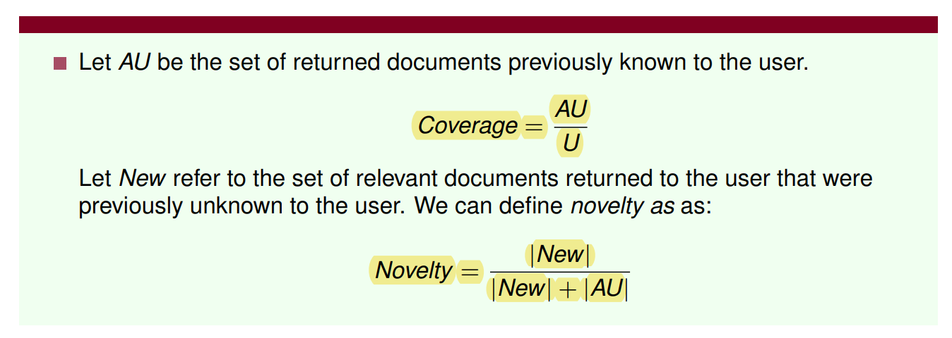

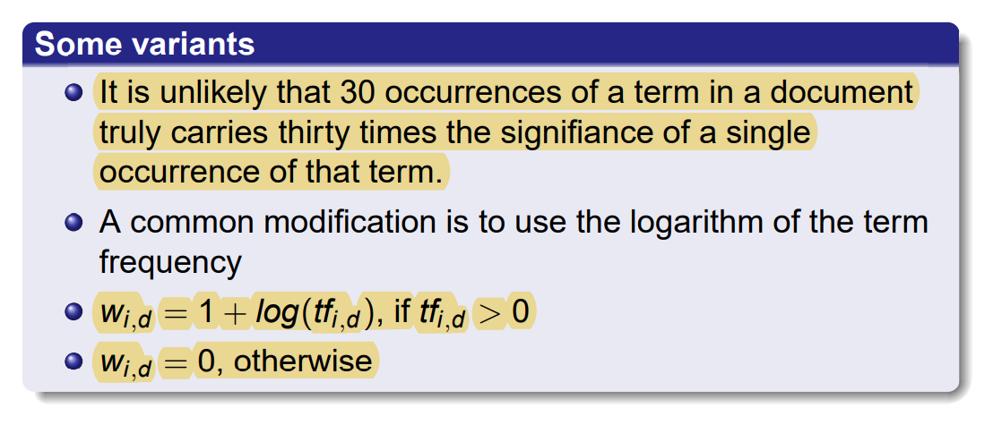

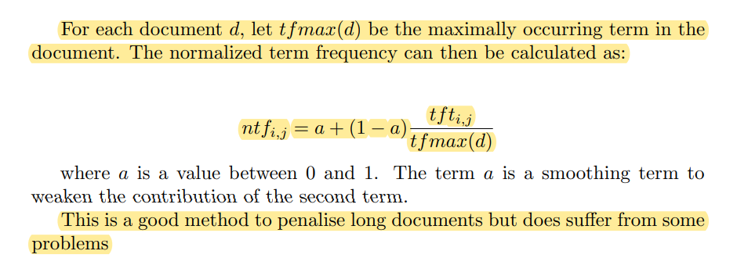

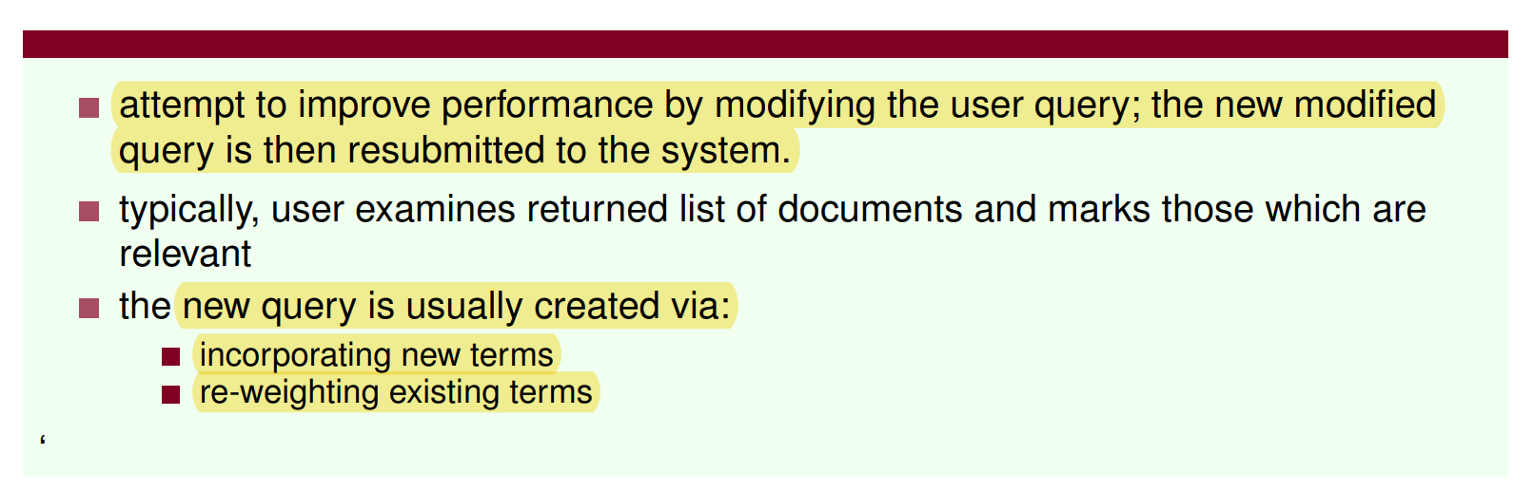

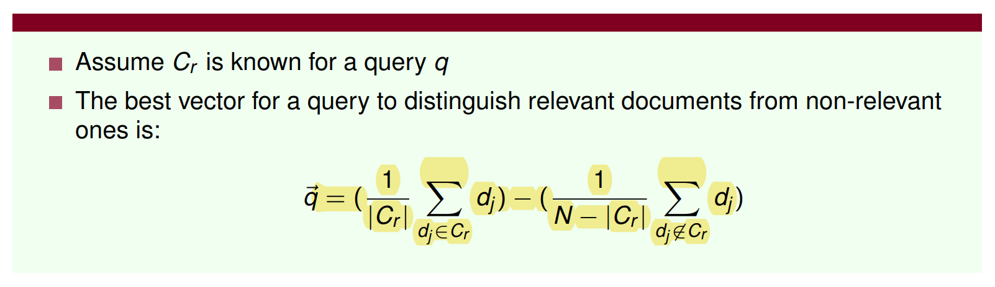

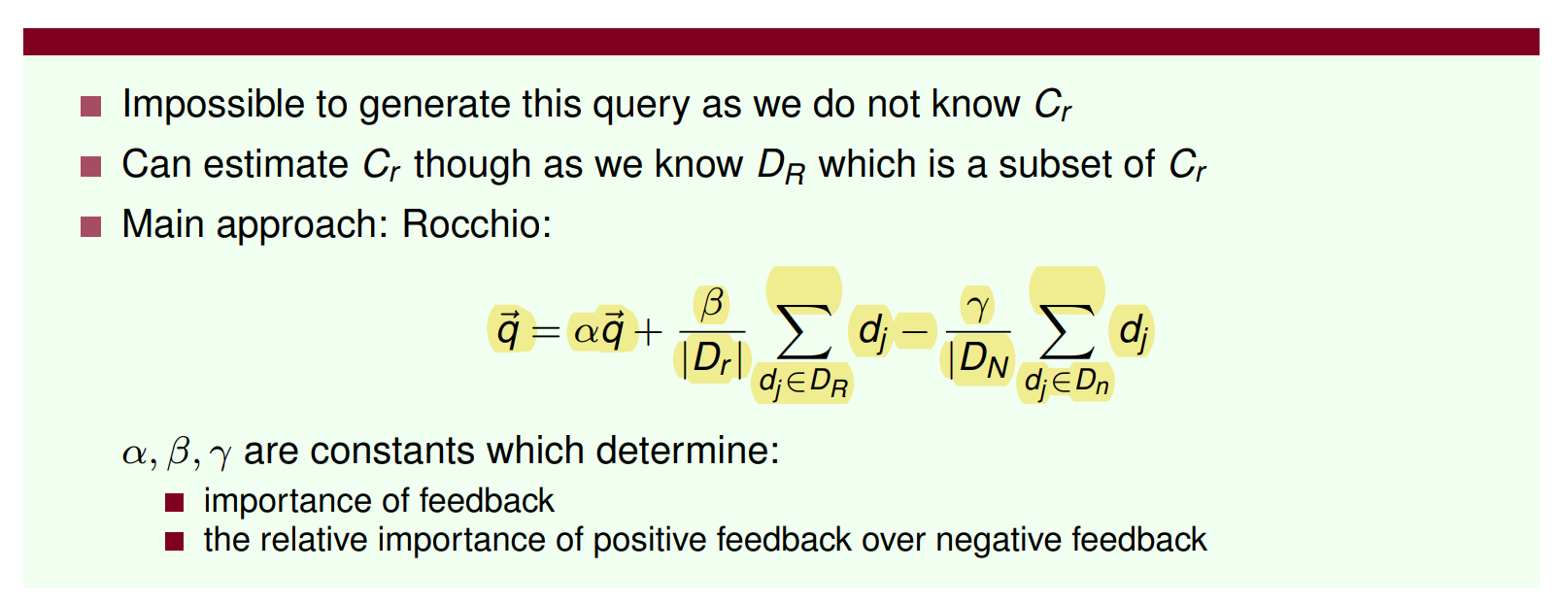

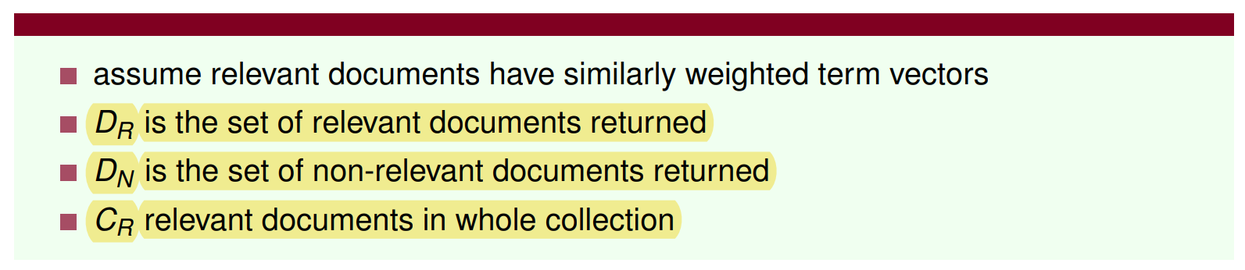

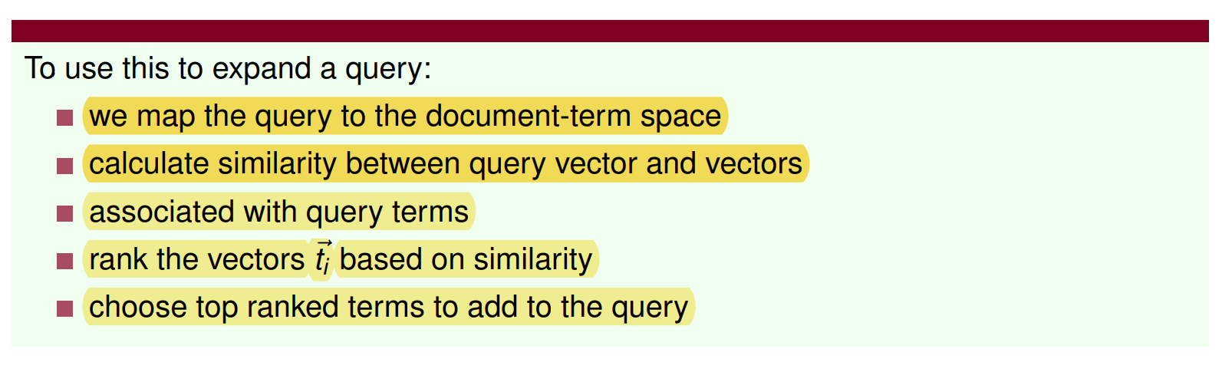

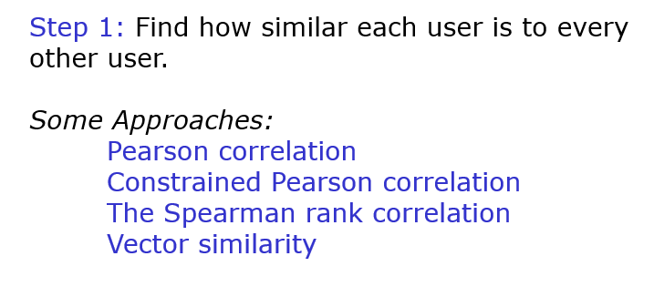

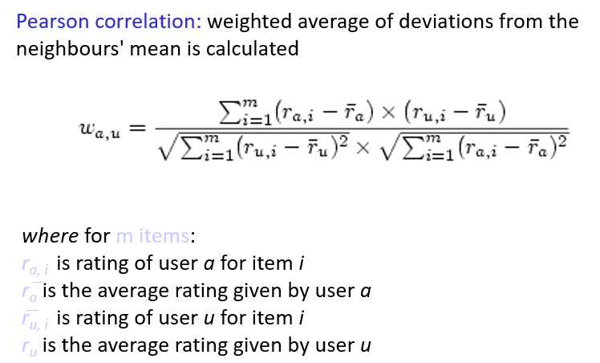

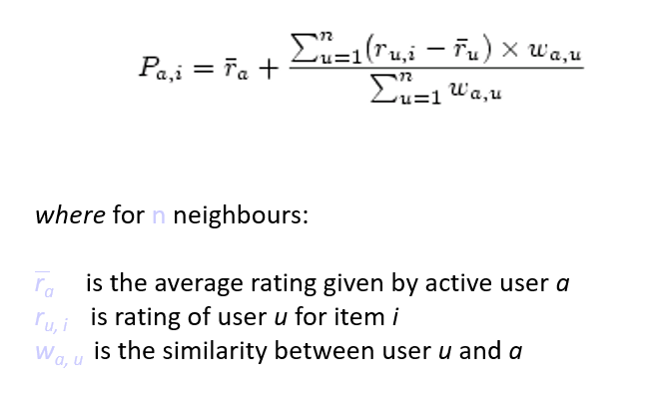

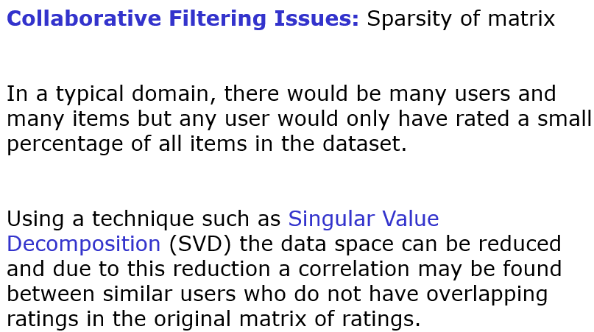

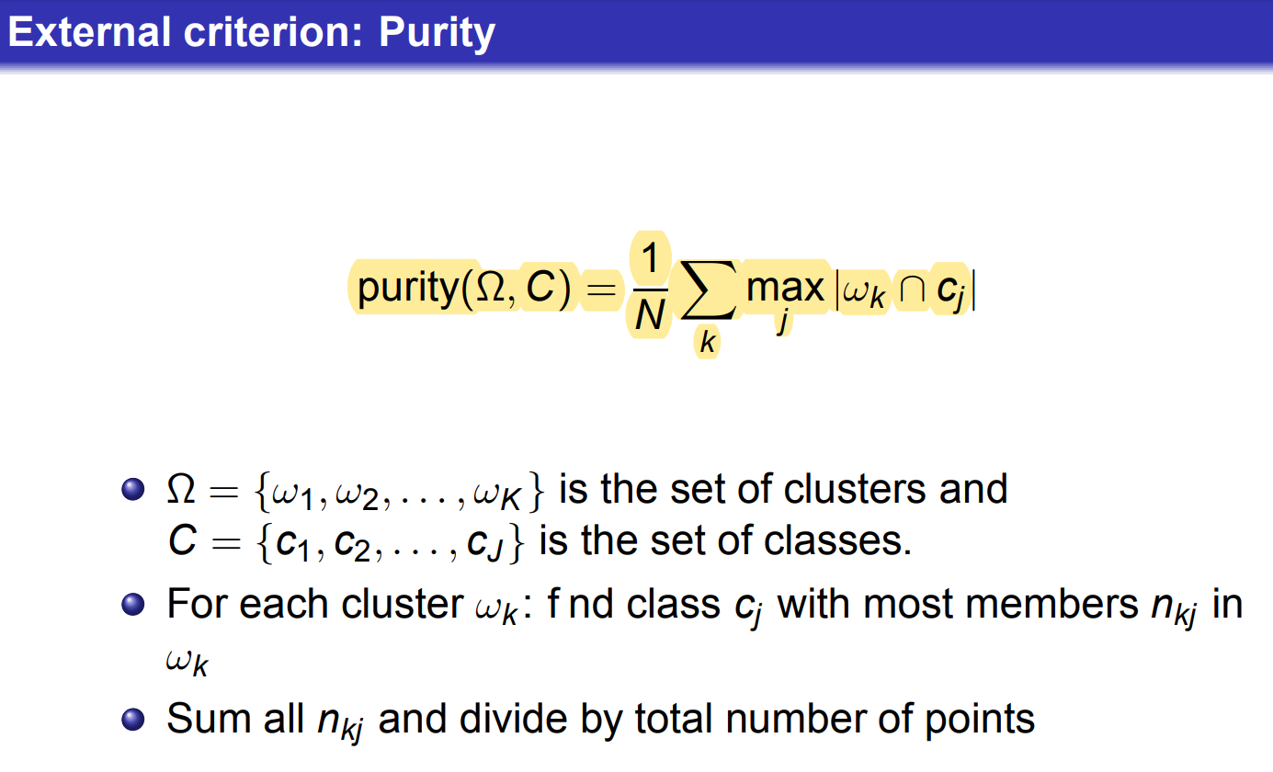

**Define the total cost of a clustering as distortion plus total cluster penalty: RSS(K)+ Kλ**

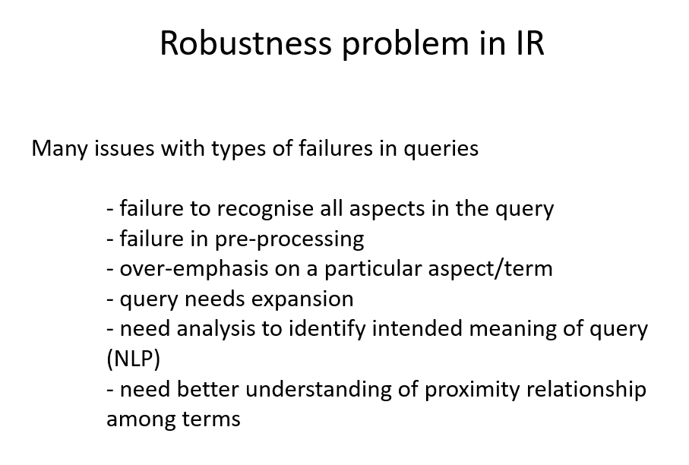

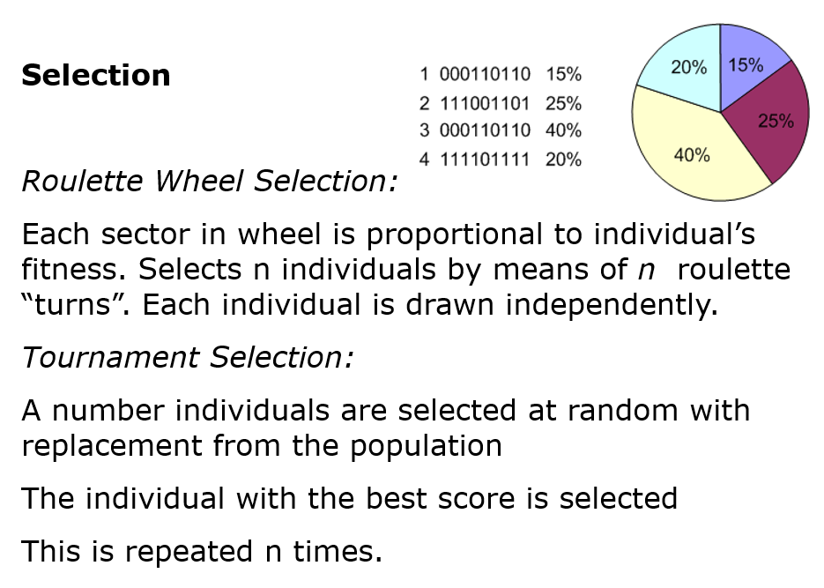

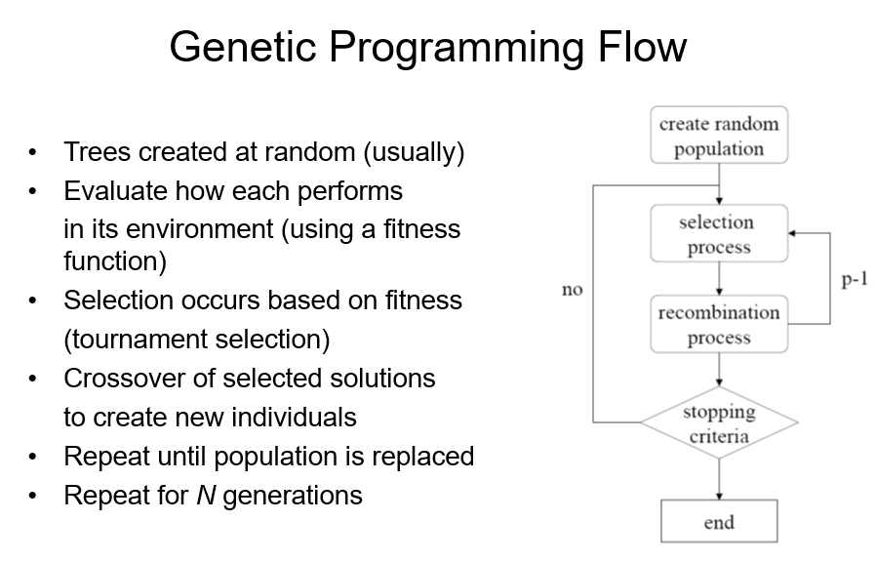

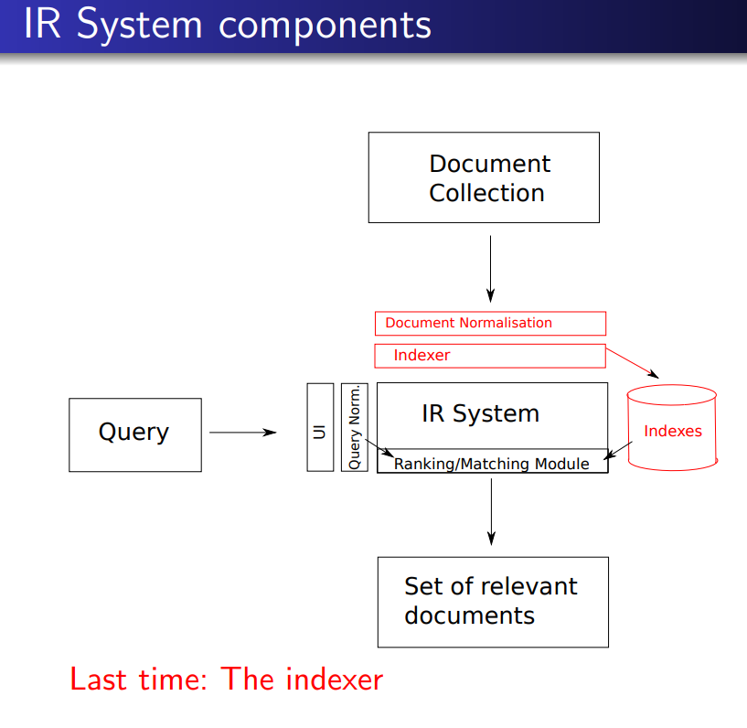

**============= Reinforcement Learning =============**

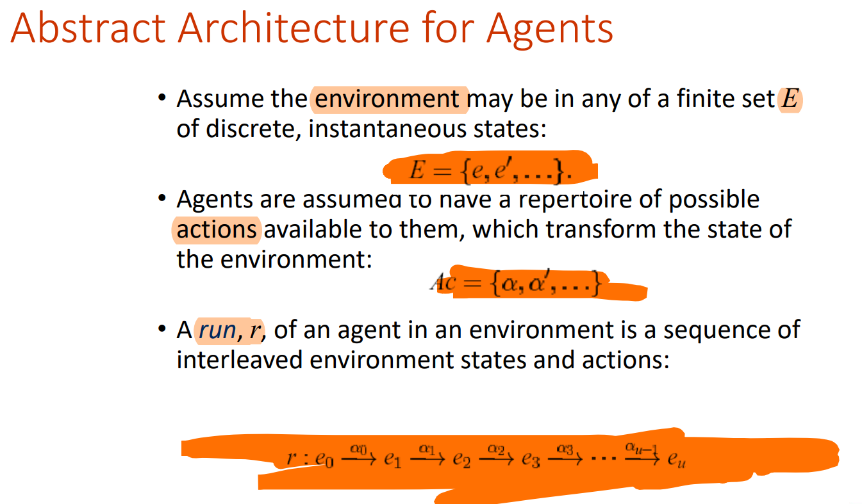

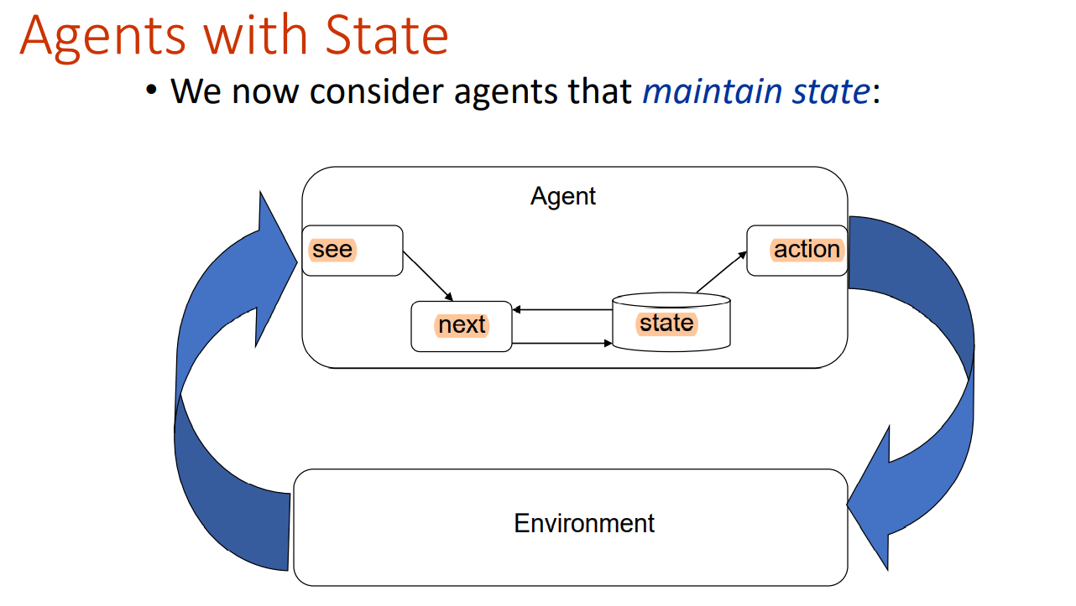

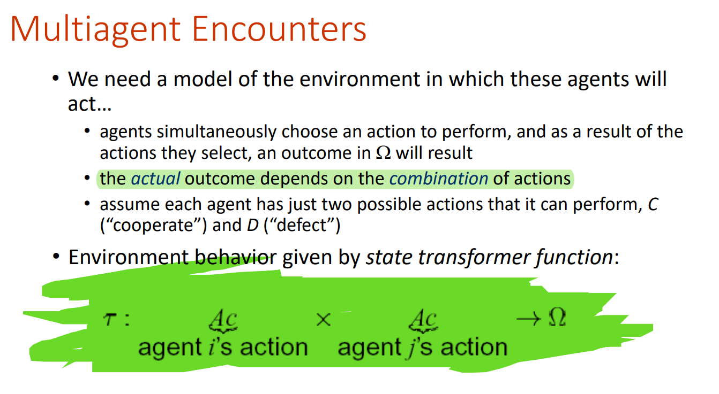

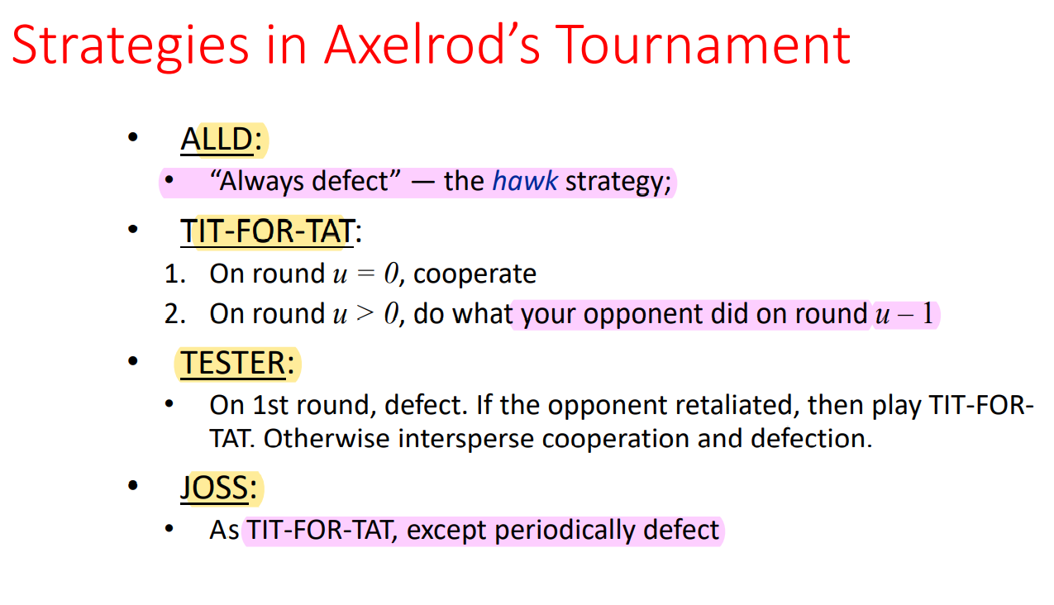

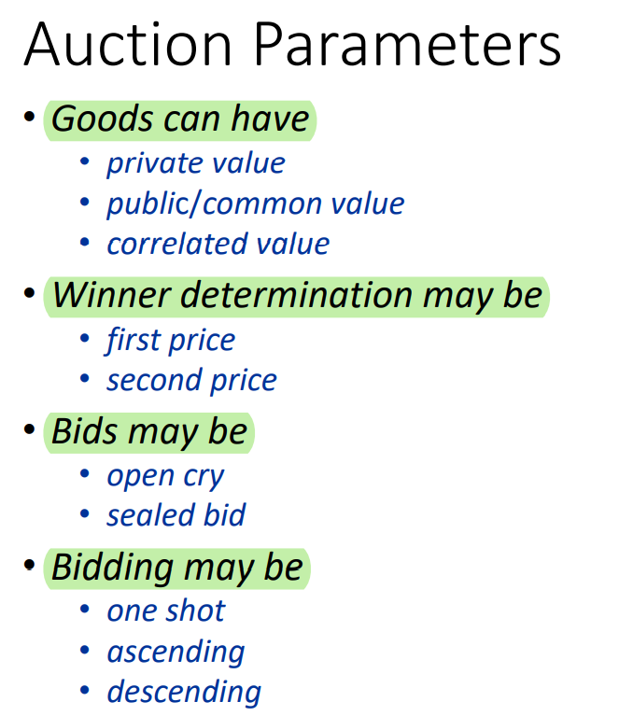

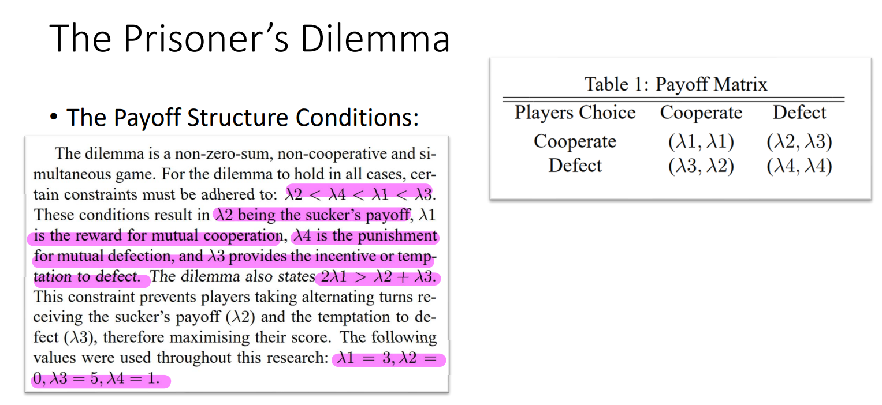

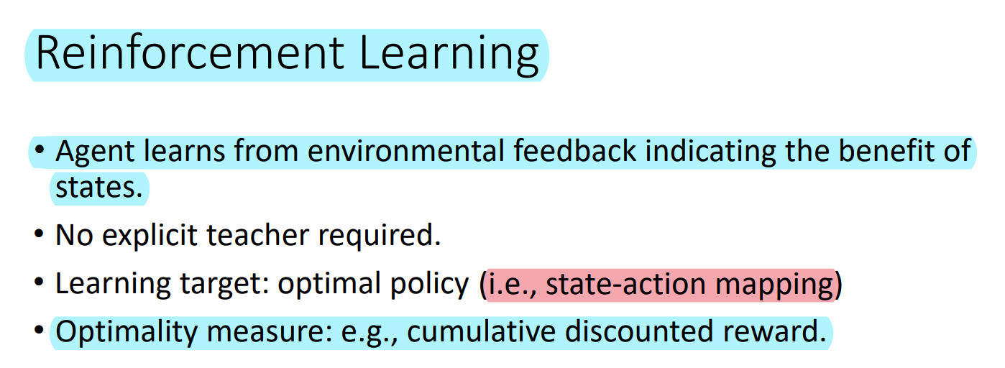

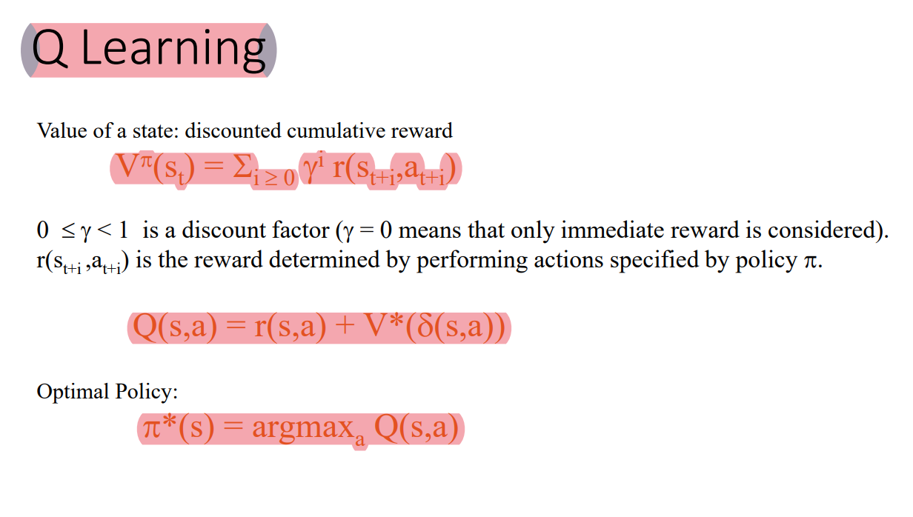

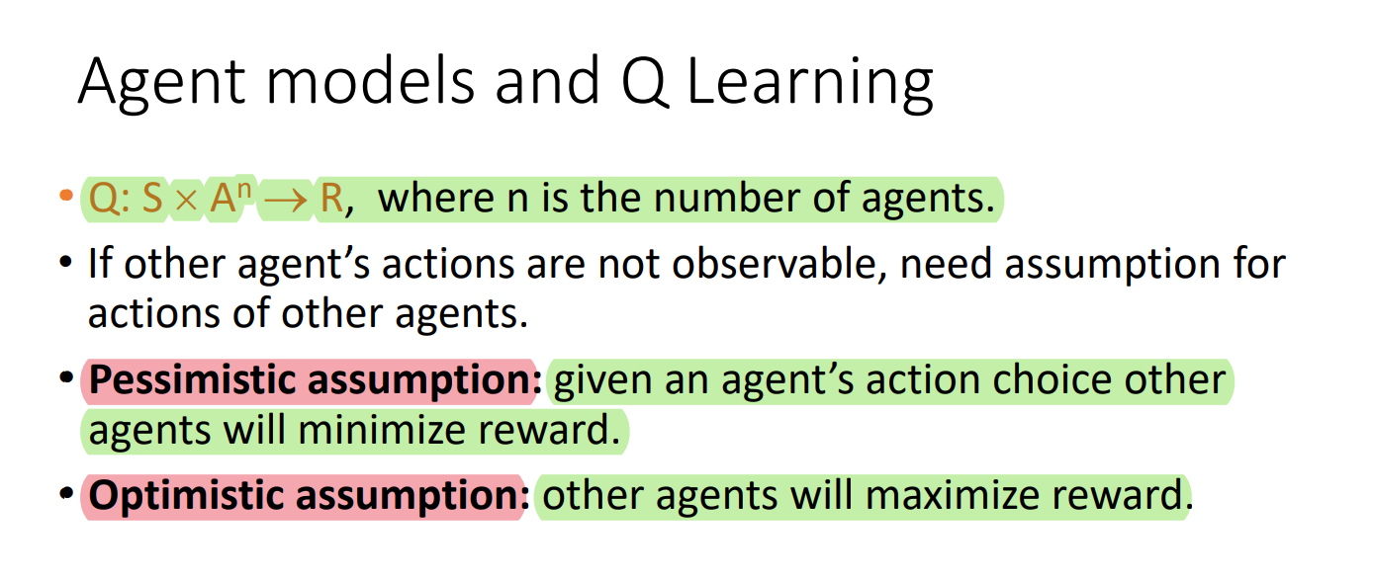

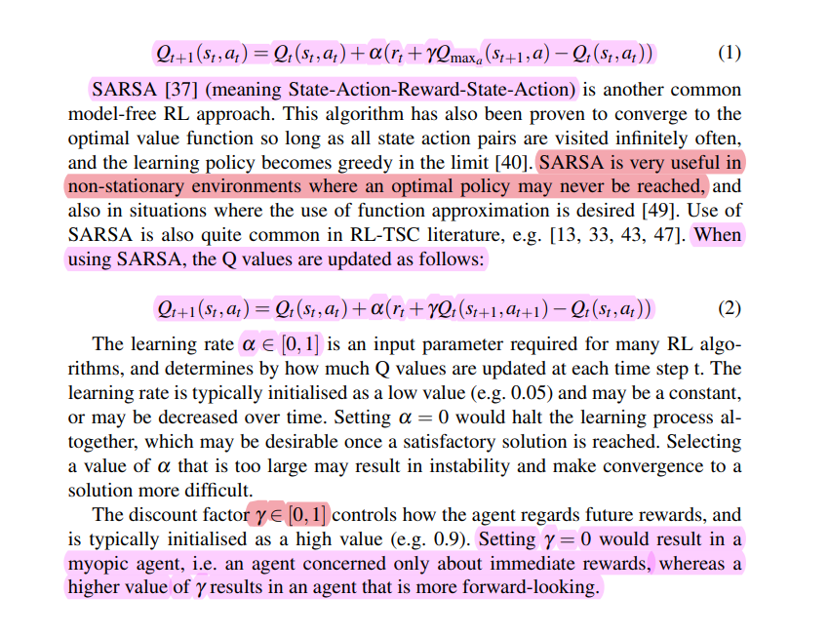

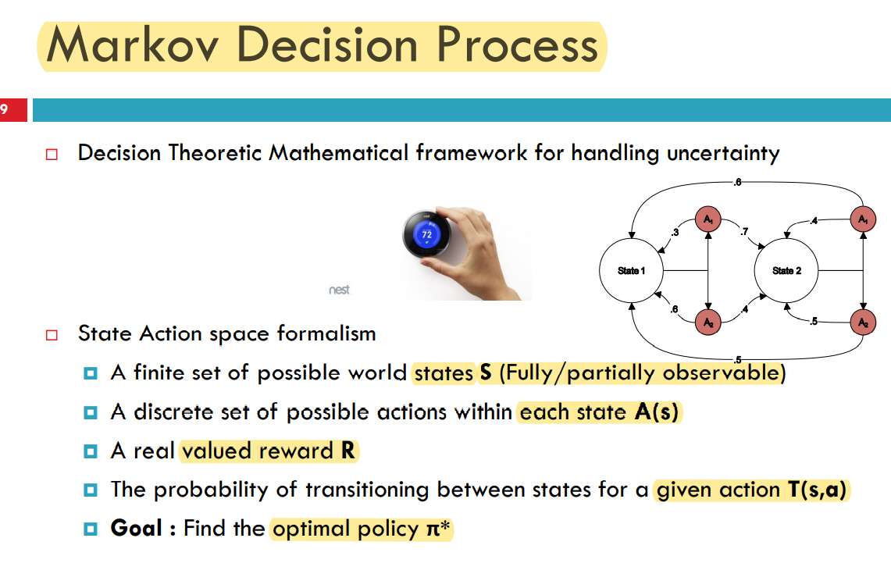

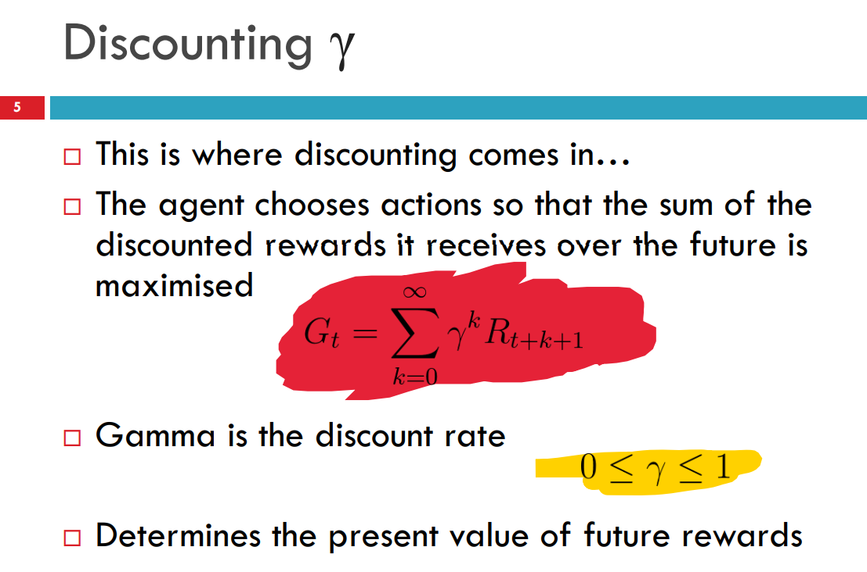

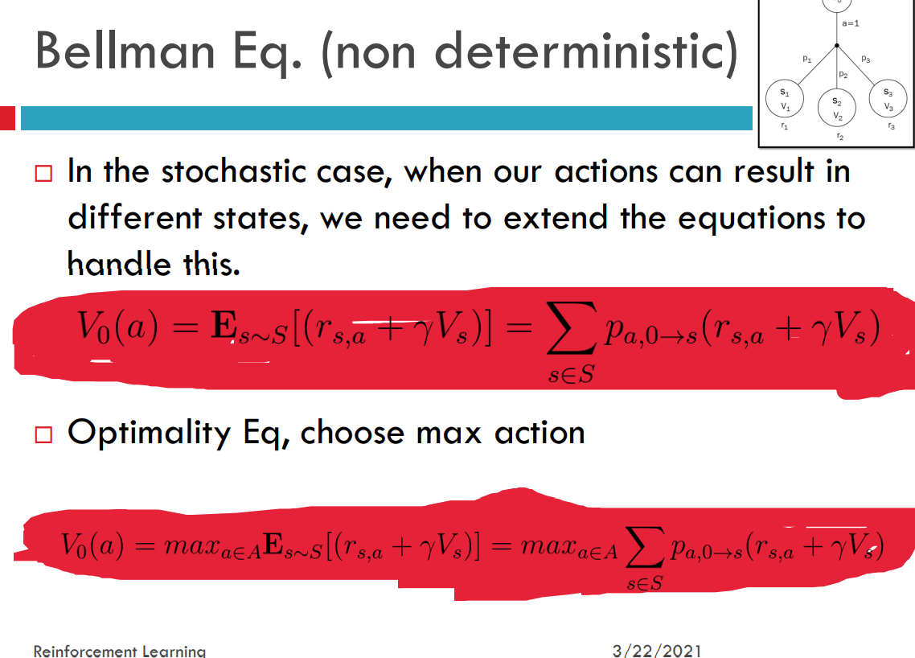

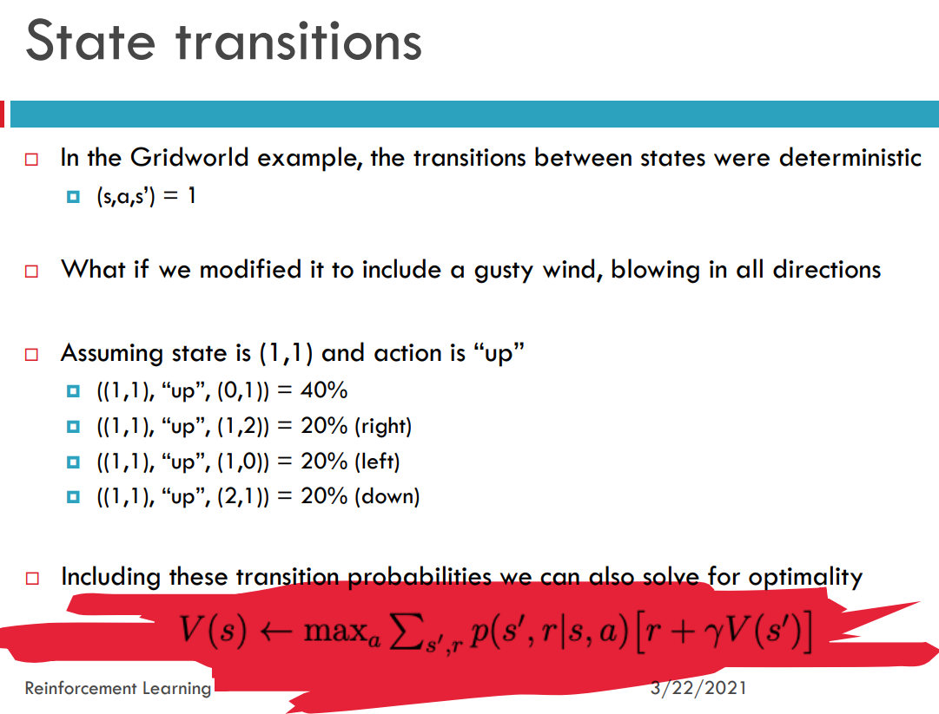

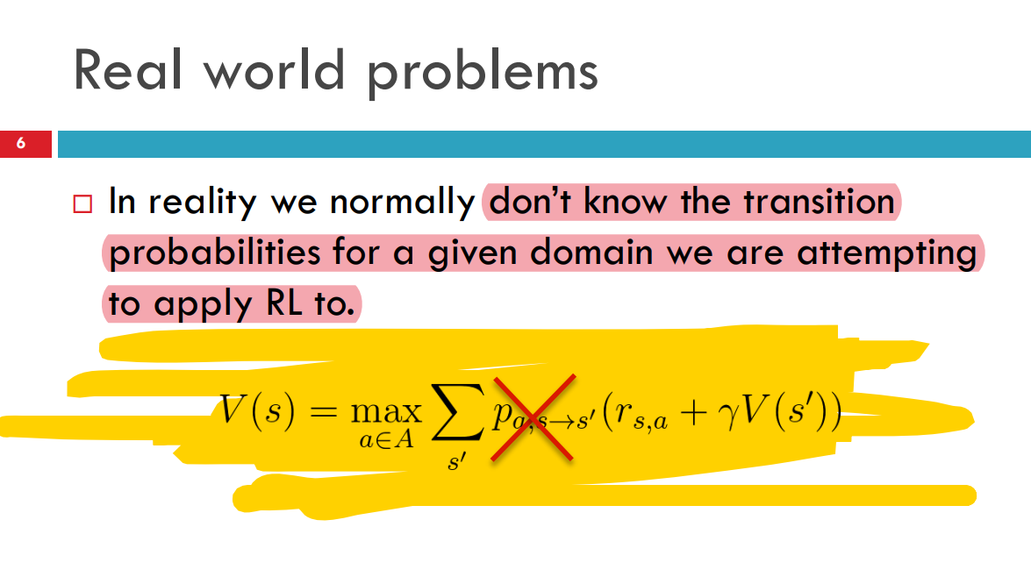

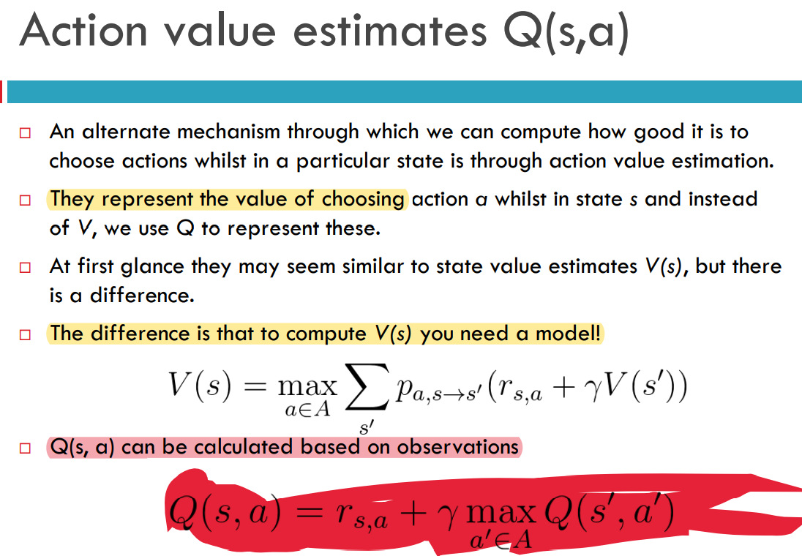

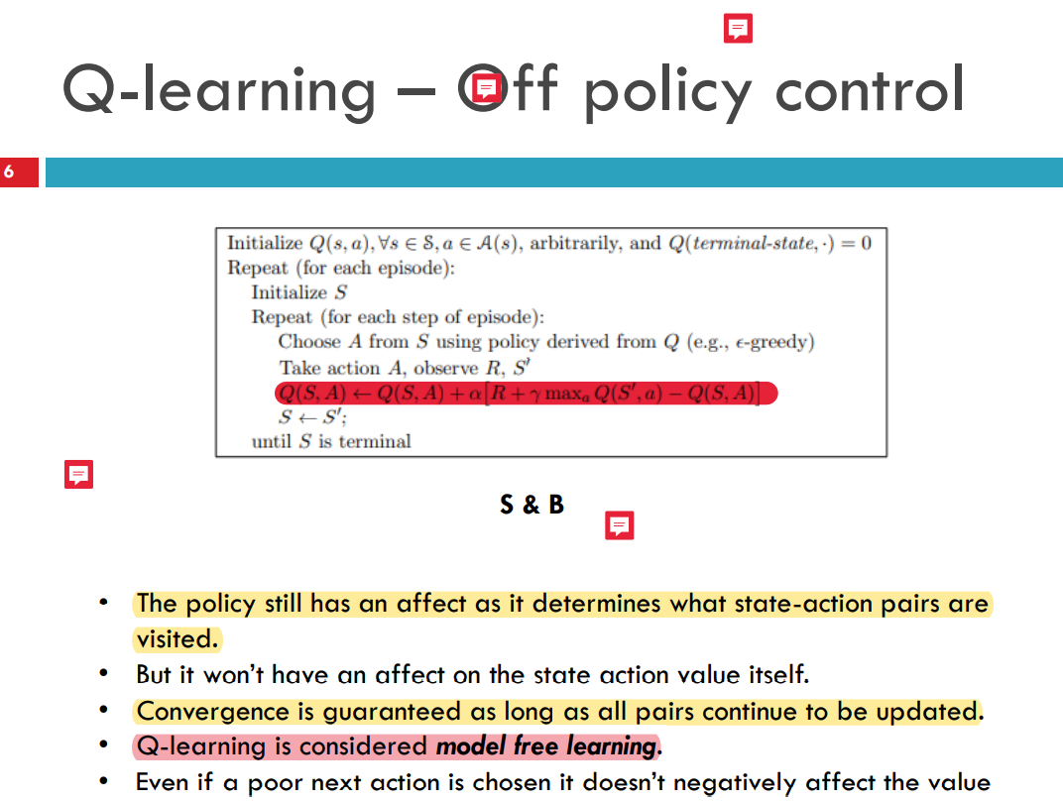

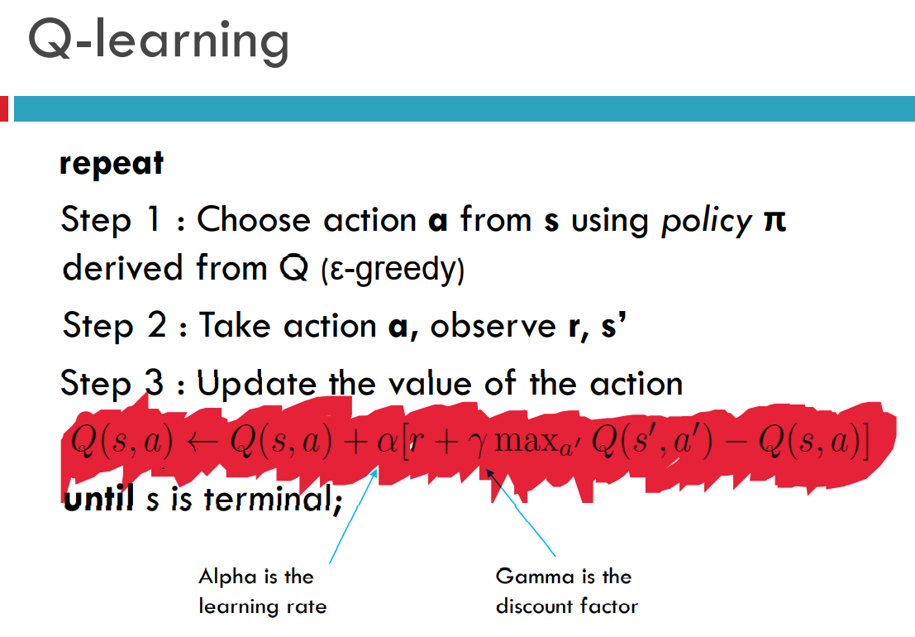

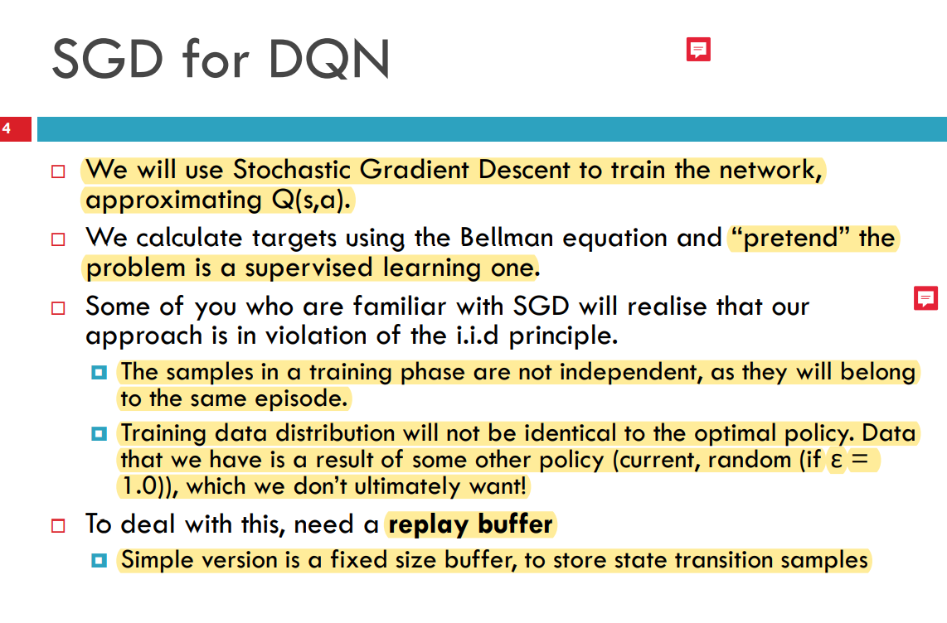

**R Data Visualization**

